Contents
Strat Sheet 3
L: ELR Job Creation 4
L: ELR State Econ Intervention 5
!: Terrorism 7
!: Terrorism 9
L: Terrorism 13
L: Terrorism 15
!: Disease Spread/Agriculture 16
!: Obesity 18
!: Starvation 20
!: Starvation 23
Social unrest 23
Causes of high prices 24
!: Starvation 25
!: Starvation 27
!: Obesity 29
!: Obesity 30
!: Obesity 31
!: Swine Flu 32
!: Environmental Destruction 33
!: Disease/poverty/starvation 34
!: Medicine/Disease 36
!: Disease 39
Alt: Activist-Researcher 44
AT: Gibson Graham 45
Alt Solves 46
Aff: Reject/Debate is political alts fail 47
A2: Quals/their evidence biased 48
Aff: Alt = ivory tower 51
Alt Solves Even if Co-opted 53
Alt Solves/L to some specific cases/!: Alienation 54
Leap of Faith Key 57
Alt: Activist-Researcher 58
Alt: Do It Yourself Micropolitics 61
DIY Solves Information/Women Empowerment 63
DIY Solves Food/undermines Cap 64
DIY Solves 66
DIY Solves 67

Strat Sheet

The impact turns should function pretty well as short modules against a lot of the cases being run in the tournament. The ELR links are mechanism links and if the debate devolves to framework you should bring that up on ground. The alt cards are very good and I believe the DIY alt to be the best. The other cards on the research-activist still apply to the DIY alt, and the DIY alt has a wealth of empirical examples to go along with being a micropolitical alt that should get you out of their ivory tower and alt fails args. Empirical examples not mentioned in the cards on DIY that you can bring up in cross-x or in the debate – the Zapatista’s in Mexico and the Factory Reclamation Movement in Argentina. I apologize for the disorganized state of the file.

L: ELR Job Creation

The affirmatives discourse of job creation hides the negatives that come tied with it – in capital’s drive for profit, the environmental, social, and labor costs that new jobs mandate are hidden, reinforcing the hegemony of capital and perpetuating environmental destruction and social inequality
DeAngelis, prof of political economy @ university of east London, 07
(Massimo De Angelis, 2007, “The Beginning of History,” pg. 27)
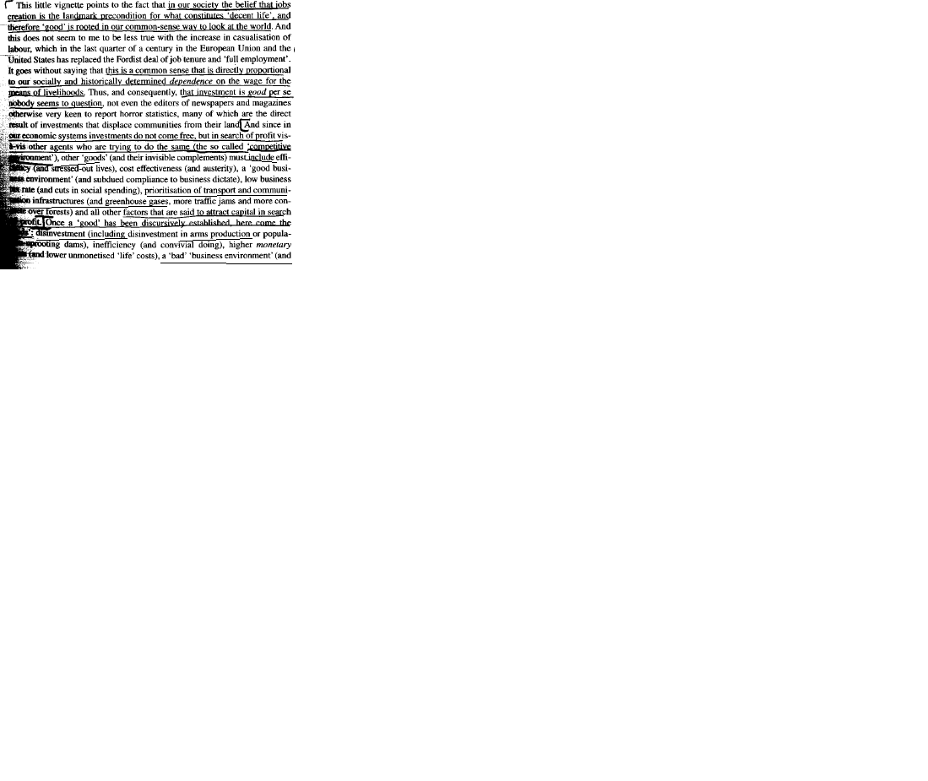
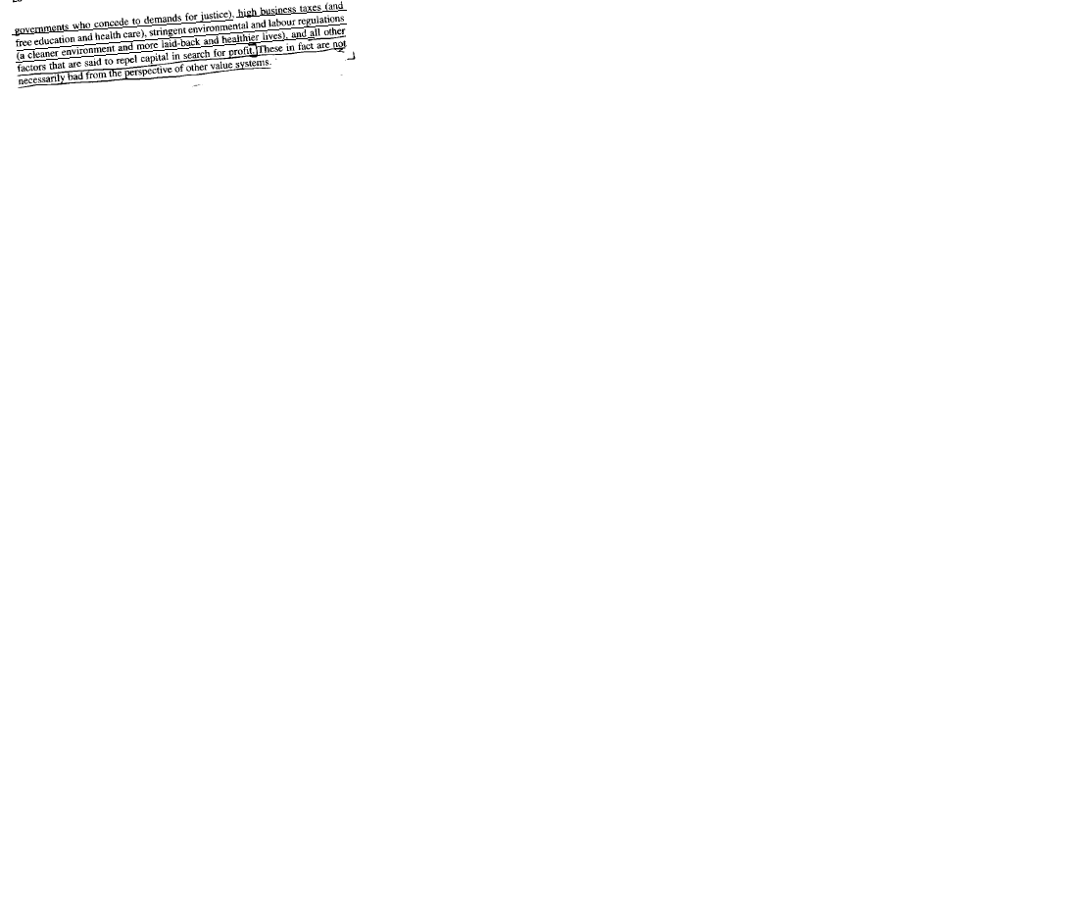

L: ELR State Econ Intervention

The 1AC is not a transition away from free-market capitalism to a new form of state-regulated prosperity – rather, the 1AC is an intervention into a crisis of capital to ensure the protection of the market and private property.
Hardt and Negri, literary theorist and political philosopher @ Duke and former teacher at the Université de Vincennes and the Collège International de Philosophie,)
(Michael Hardt and Antonio Negri, “Multitude,” pg. 167-168, 2004)
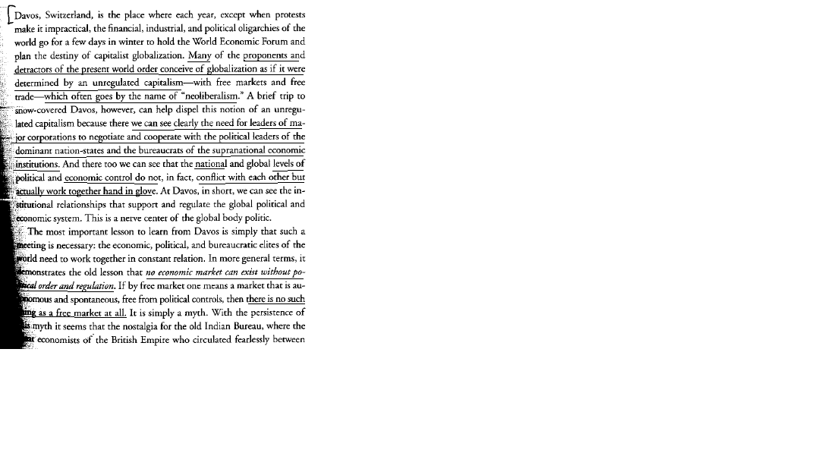

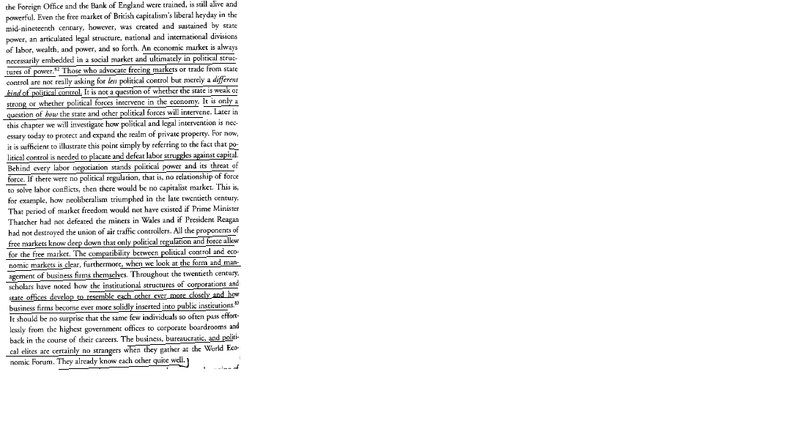

!: Terrorism

Terrorism is inevitable under cap – state enacted violence against other nations and funding reactionary groups to fight ideological enemies
Decker, International Bolshevik Tendency, 23 October 04
Josh Decker, International Bolshevik Tendency, socialist revolutionary group, “Paranoia and Hypocrisy in the Age of Imperialism,” http://www.bolshevik.org/1917/no27/Terrorism%2015%20feb.html)
Nine days after the attacks, in an address to a joint session of Congress, George W. Bush took advantage of Americans’ fear and sense of vulnerability to launch his cynical “war on terror.” The Commander-in-Chief of the military apparatus that deliberately exterminated hundreds of thousands of civilians in Hiroshima and Nagasaki to “shock and awe” the Japanese into submission and intimidate the Soviets, proposed to launch a war—on behalf of the entire “civilized world”—against “terrorism.” It was reminiscent of Ariel Sharon—the butcher of Sabra and Shatila—talking about eradicating “terrorist nests” in Palestinian communities in Gaza.
The U.S. “war on terror” is intended to terrorize other countries, in the first instance the so-called rogue states, into submitting to the dictates of American imperialism. Peter Ustinov once aptly observed that “terrorists” are people who have bombs but no air force to deliver them. Those officially designated “terrorists” tend to be the retailers—the wholesalers are the U.S. and other major imperialist powers (supported, in their own duplicitous, “peace-loving” ways, by weaker imperialists like Denmark and Canada).
Origins of Al Qaeda
The connection between wholesalers and retailers in the terror business is perfectly illustrated by Al Qaeda. We should not forget how Osama bin Laden and other leading cadres of Al Qaeda got their start—they were trained and equipped by the CIA to fight a jihad against the Soviets in Afghanistan in the 1980s. (This is the same period in which the United States and Britain were providing Saddam Hussein with his infamous “weapons of mass destruction” to use during his war with Iran).
In 1978, when the pro-Soviet People’s Democratic Party of Afghanistan (PDPA) took power in Kabul, it immediately began distributing land to the peasants, reduced debt payments for the poor, and lowered the bride price. The PDPA also encouraged girls to go to school. The semi-feudal landowners, moneylenders and reactionary Muslim clerics considered this a threat to their traditional way of life and, aided by the CIA, began to organize an insurgency. In December 1979 the Soviet Union countered by sending its army into Afghanistan to back the left-nationalist government.
Zbigniew Brzezinski, Jimmy Carter’s national security adviser at the time, later admitted that the U.S. had been actively supporting resistance by the clerics and landholders for months before the Soviets’ intervention:
“[I]t was July 3, 1979 that President Carter signed the first directive for secret aid to the opponents of the pro-Soviet regime in Kabul. And that very day, I wrote a note to the president in which I explained to him that in my opinion this aid was going to induce a Soviet military intervention....
“That secret operation was an excellent idea. It had the effect of drawing the Russians into the Afghan trap.…”
— Le Nouvel Observateur, Paris, 15-21 January 1998
The U.S. spent billions of dollars training and equipping 100,000 radical Islamic mujahedin whose leaders were among those who, in the 1970s, had been throwing acid in the faces of unveiled women at Kabul University. Ronald Reagan praised the Afghan reactionaries as “freedom fighters” and called them the “moral equivalent” of America’s founding fathers.

!: Terrorism

Capitalism is terrorism – the abuses of imperialist nations in the name of economic self interest are what makes terrorists attack and the damage done by capitalist nations far outweighs any terrorist threats
Decker, International Bolshevik Tendency, 23 October 04
Josh Decker, International Bolshevik Tendency, socialist revolutionary group, “Paranoia and Hypocrisy in the Age of Imperialism,” http://www.bolshevik.org/1917/no27/Terrorism%2015%20feb.html)
After the Soviet retreat, the U.S. lost interest and a bloody war erupted among competing mujahedin factions that was eventually won by the Pakistani-backed Taliban in 1996. The United States welcomed the victory of the Taliban as a stabilizing factor in a region that, after the collapse of the Soviet Union, had assumed renewed importance due to the discovery of huge oil and natural gas deposits in the lands bordering the Caspian Sea. (The U.S. was particularly interested in the possibility of building a pipeline from Turkmenistan, through Afghanistan to Pakistan. This route would bypass both Iran, a country designated by the U.S. as part of the “axis of evil,” and Russia, which opposes American expansion in the region.) The fact that the Taliban was a brutally repressive, misogynist theocracy was a matter of complete indifference to the apostles of liberty and freedom—Washington’s only problem with the new Afghan government was that it was not sufficiently pliable. So plans were being laid long before 9/11 for installing a friendlier regime in Kabul. The destruction of the World Trade Center in New York in September 2001 provided a perfect pretext for removing the Taliban and establishing a string of military bases across formerly Soviet Central Asia—all in the name of fighting “terror.” The real reason was to undercut Russian and Chinese influence and insert the American military into the region.
The Russians have been waging a reactionary war for more than a decade to crush the attempt by the Chechen people to win their independence. The U.S. has been happy to see the Russian military bogged down in a protracted guerrilla conflict in Chechnya and has been reluctant to include the Chechens as targets in the global “war on terror.” Even after the horrific massacre of Russian school children in Beslan on 1 September [2004], the corporate media in the U.S. refused to endorse the Kremlin’s brutal campaign against the Chechen resistance. The New York Times wrote that “despair and anger at Russians” drove Chechens to suicide attacks and observed:
“Mr. Putin is also responsible for Russia’s stubborn refusal to deal with the political dimensions of Chechen separatism, as if punishing military offensives, puppet governments and fraudulent elections could somehow make the problem go away.”
— New York Times, 14 September 2004
Yet, like the rest of the American media, the Times “stubbornly refuses” to take a similarly broadminded approach to the question of why so many Iraqis are prepared to sacrifice their lives to deliver blows to American forces occupying their land. The transparently stupid assertions by President Bush that “the terrorists” hate America because of its freedom and democracy explain nothing. A retired U.S. Air Force lieutenant-colonel, Robert Bowman, offered a far more plausible explanation when he noted that the United States is:
“...the target of terrorists because, in much of the world, our government stands for dictatorship, bondage and human exploitation. We are the target of terrorists because we are hated. And we are hated because our government has done hateful things.”
— National Catholic Reporter, 2 October 1998
‘Hateful Things’
The United States and every other imperialist power does violent and “hateful things” to the oppressed masses of the world because a social system that condemns half the world’s population to life on less than $2 a day for the benefit of a tiny handful of billionaires can only be maintained by constant, massive brutality.
Within two months of the U.S.-led invasion of Afghanistan in 2001, more civilians were killed than perished in New York on 11 September. Tens of thousands of Iraqis have been killed by the “coalition of the willing” since March 2003 when the U.S. blitzkrieg was launched with an aerial bombardment designed to “shock and awe,” i.e., terrorize, the population. Some 200,000 Iraqis were killed by the imperialists in the 1991 Gulf War. And more than a million Iraqis, many of them children, died during the 1990s as a result of the sanctions imposed by the United Nations on behalf of the U.S.-led imperialist coalition.
Last spring when four American mercenaries were killed in Falluja, the U.S. responded by attacking the city and killing 600 civilians. During the past few weeks U.S. aircraft have been relentlessly bombing residential neighborhoods in Falluja, as a prelude to the long-awaited assault. There is barely a pretense of winning hearts and minds—the clear intent is to terrify the population into submission. But it is not working. As one young Iraqi told the New York Times (14 September 2004): “When the Americans fire back, they don’t hit the people who are attacking them, only the civilians. This is why Iraqis hate the Americans so much. This is why we love the mujahedeen.” The horrors of imperialist terrorism have been highlighted by recent reports of torture, rape and murder of prisoners in Baghdad’s Abu Ghraib prison and other facilities. In waging its “war on terror” the Bush administration decided to suspend the Geneva Convention for any prisoners it chose to designate as “unlawful combatants,” including those held at Guantanamo Bay, Cuba, so that they could be routinely subjected to what the New York Times decorously refers to as “brutal interrogation techniques,” i.e., torture. At a U.S. Senate hearing last month General Paul Kern revealed that as many as 100 people detained by the American military in Iraq have not been officially recorded, to avoid the risk of embarrassing investigations into their torture or execution (Washington Post, 10 September 2004).
Imperialist rule has always been characterized by brutal repression. The French and American imperialists butchered two million Vietnamese workers and peasants in a long, losing counterrevolutionary war. At least half a million people were slaughtered in 1965 in a CIA-supported coup in Indonesia. Tens of thousands were killed in Chile under Augusto Pinochet, whose military dictatorship was backed by the U.S. During the 1980s, the CIA’s “contra” terrorists in Nicaragua murdered thousands of people, many of them schoolteachers and healthcare workers, in an attempt to undermine the left-nationalist Sandinista regime. Of course, none of this qualifies as “terrorism” in the capitalist media.
A few months ago the Bush administration ordered three anti-communist Cubans with long-standing ties to the CIA to be admitted to the U.S. They had been convicted in Panama of planning to detonate 33 pounds of explosives to kill Fidel Castro, along with dozens of university students, when he visited in 2000. These terrorists are welcome in the United States.
In fact the U.S. “war on terror” provides employment for many terrorists. A good example is Ayad Allawi, the long-time CIA asset appointed by the U.S. as Iraqi “prime minister” last June, who Bush has praised as a “strong leader” in the fight against international terrorism. In the 1970s, Allawi ran a Mukhabarat death squad for Saddam Hussein. During the 1990s, while on the CIA payroll, he helped organize several bombings in Iraq, including one that killed several schoolchildren.
Bush’s chief ally in the “war on terror” is British Prime Minister Tony Blair. In the 1920s, in an attempt to put down a popular uprising in Iraq, British airplanes dropped poisonous mustard gas in civilian areas. Eighty-odd years later, Blair sought to rationalize the invasion of Iraq by feigning outrage that Saddam Hussein had used chemical weapons “against his own people.” Blair also neglected to mention that Britain and the U.S. had supplied the weapons in the first place.
Canada officially sat out the Iraq war, though Canadian military planners and 31 soldiers participated alongside British and American troops. Three Canadian warships with 1,300 sailors were in the Persian Gulf helping to protect American aircraft carriers. Canada’s most important contribution was sending 3,000 soldiers to Afghanistan to free up American troops for Iraq. U.S. Ambassador Paul Cellucci, commenting on the Liberal government’s refusal to officially endorse the assault, pointed out: “Ironically, the Canadians indirectly provide more support for us in Iraq than most of those 46 countries that are fully supporting us” (Globe and Mail, 31 March 2003). Canada is what we call a “jackal” imperialist—it tags along behind the big predators and picks up the scraps they leave behind.
‘To Impose the Will of the United States’
The pretext for the attack on Afghanistan was that it was harboring terrorists. In a desperate attempt to ward off an imminent American assault, the Taliban offered to expel bin Laden and his cronies, but the U.S. wasn’t interested. Al Qaeda was never the issue. The war on Afghanistan was part of a larger strategic military plan for control of Central Asia and the Middle East.
In its September 2001 Quadrennial Defense Review Report, the U.S. Department of Defense referred to the importance of “access to key markets and strategic resources,” and noted:
“U.S. forces must maintain the capability at the direction of the President to impose the will of the United States and its coalition partners on any adversaries including states or non-state entities. Such a decisive defeat could include changing the regime of an adversary state or occupation of foreign territory until U.S. strategic objectives are met.”
It’s no coincidence that most of the countries targeted in the supposed “war on terror” are either sitting on important oil deposits or are strategically located in relation to them. Iraq, which possesses the world’s second-largest oil reserves, is right next door to Saudi Arabia which has the largest. Iran, on Iraq’s other flank, also possesses important oil and gas deposits. In a speech delivered on the first anniversary of the criminal assault on Iraq, Bush claimed that the “ultimate ambition” of “the terrorists” was “to control the peoples of the Middle East” and “blackmail the rest of the world with weapons of mass terror.” That’s U.S. foreign policy in a nutshell.
Under the Bush Doctrine, the United States claims the right to preemptively attack any country which might possess “weapons of mass destruction” which could fall into the hands of terrorists at some point in the future. That of course was the excuse for invading Iraq. Meanwhile, the U.S. is planning nuclear first strikes on “rogue states.” In 2002, according to a leaked Pentagon document, there were seven countries on that list: China, Russia, Iran, Iraq, North Korea, Syria and Libya (Daily Mirror [London], 11 March 2002). Cuba, too, is in grave danger. The only reason it is not on the to-be-nuked list is because of its proximity to Florida. The imperialists are anxious to uproot the system of collectivized property and restore capitalism in China, Cuba and North Korea. While revolutionaries advocate the overthrow of the ruling Stalinist bureaucracies through workers’ political revolution, we also stand for the unconditional defense of these states against both internal counterrevolution and imperialist aggression—and we defend their right to possess nuclear arms.

L: Terrorism

The war on terror is a reactionary capitalist construction to justify the expansion of military control and the defeat of labor efforts
Decker, International Bolshevik Tendency, 23 October 04
Josh Decker, International Bolshevik Tendency, socialist revolutionary group, “Paranoia and Hypocrisy in the Age of Imperialism,” http://www.bolshevik.org/1917/no27/Terrorism%2015%20feb.html)
The “war on terror” is fought on two fronts. In addition to extending U.S. military power globally, it also serves as a tool for strengthening the position of the American ruling class at home by hobbling domestic political resistance, particularly from the left and labor movement. The social basis of capitalist profit is the exploitation of living labor in the process of material production. Without the socially necessary, productive activity of the working class, capitalist society would not function. Any imperialist power that seeks to dominate the planet must first ensure the subservience of its own proletariat.
The color-coded “war on terror” uses a time-honored mechanism for getting the oppressed to identify with their oppressors: fear of an external danger. Today in North America, particularly in the U.S., there is a concerted campaign to promote a level of fear, bordering on paranoia, that has resulted in widespread acquiescence to a whole range of repressive measures that many Americans would not normally tolerate. The elaborate security checks, fink lines, data mining of credit cards, library and health records, the “orange” and “red” alerts, are all accepted because of the supposed danger of terrorist attacks.
Do you know how many people were killed by terrorist attacks in the United States in 2002? In 2003? This year? No one. And yet the avalanche of anti-democratic legislation continues, all under the guise of protecting American “freedom.” Marxists have no illusions in the capitalists’ commitment to democracy, and we remember that the right to free speech, freedom of assembly, the right of habeas corpus and all other democratic rights were won through hard social struggle. They must be jealously guarded against infringement by the ruling class.
At a Senate hearing in December 2001, U.S. Attorney General John Ashcroft openly attacked those who dared to complain about the assault on civil liberties: “Your tactics only aid terrorists for they erode our national unity and diminish our resolve. They give ammunition to America’s enemies and pause to America’s friends” (CNN.com, 7 December 2001).
The supposed “war on terror” has meant attacks on organized labor, immigrants and minorities (especially Muslims, South Asians and Arabs). Since September 2001, more than 5,000 foreign nationals have been arbitrarily detained by the U.S. Justice Department as “suspected terrorists.” Of those 5,000 only one has been convicted by a jury of anything related to terrorism. And last month, a federal judge in Detroit threw out that conviction citing a lack of evidence and gross prosecutorial misconduct.
The U.S. government has drawn up secret, arbitrary “no-fly” lists of Muslims, leftists, peace activists and other suspected “dissidents” who are not allowed aboard airplanes in the U.S. This is pure political harassment. The workers’ movement has a vital interest in fighting all such attacks on democratic rights because an attack on any minority is an attack on all the oppressed and exploited. That is clear if you look at the scope of the Patriot Act, which defines “domestic terrorism” as acts that “appear to be intended” to “influence the policy of a government by intimidation or coercion” or “to intimidate or coerce a civilian population.” The law was deliberately formulated so that it could be interpreted as applicable to picket lines, strikes or demonstrations. Proposals are floating around the U.S. Congress to ban unions for anyone deemed essential to “homeland security” (Washington Post, 27 September 2004), a category the government would like to expand to include longshore and other unionized workers. This is a proposal for government-organized union busting, under the guise of a “war on terror.” The increasingly authoritarian climate in the U.S. was evident during the Democratic and Republican national conventions this summer, both of which featured massive cop intimidation, police pens, preventative arrests and other preemptive measures to suppress dissent. The FBI recently seized internet servers which host various Indymedia websites on the grounds that in the course of exposing police brutality by undercover cops in Europe, “personal information” had been revealed. In Italy, Indymedia is currently being investigated for supposed links to “terrorism.” And here in Toronto people remember [police chief] Julian Fantino’s denunciation of OCAP [Ontario Coalition Against Poverty] as a “terrorist” group after the police riot at Queen’s Park in June 2000.

L: Terrorism

Terrorism is a social construction used to hide capitalism’s abuses and justify it’s expansion
Decker, International Bolshevik Tendency, 23 October 04
Josh Decker, International Bolshevik Tendency, socialist revolutionary group, “Paranoia and Hypocrisy in the Age of Imperialism,” http://www.bolshevik.org/1917/no27/Terrorism%2015%20feb.html)
The capitalist media and politicians sometimes refer to the blows struck against the imperialist occupation by the Iraqi resistance as “terrorist attacks.” There is no question that, as in Afghanistan, most of those actively resisting the imperialist occupation embrace extremely reactionary and virulently anti-working class ideologies. But that does not change the fact that the peoples of Iraq have a right to determine their own future free of coercion by foreign invaders and their puppets. In Iraq today the issue is not one of democracy versus dictatorship. It is a question of whether or not the U.S./British imperialist “coalition” will be able to re-impose colonial rule.
The “war on terror” is essentially a marketing device designed by the American ruling class to promote its campaign for global supremacy. It is used both to justify military adventures abroad and vicious repression at home. Under capitalist rule things are rarely called by their right names: exploitation is fair exchange, war is peace and occupation is liberation. The so-called war on terror is no exception. It is, in reality, a war of terror.

!: Disease Spread/Agriculture
US agriculture companies increasingly monopolize the market resulting in disease spread and brutal exploitaton of workers
Piette, staff writer, 7/8
(Betsey Piette, Worker’s World staff writer, Worker’s World newspaper, “Food Inc.’: Another Capitalist Crisis,” 7/8/09, http://www.workers.org/2009/us/food_inc_0716/)
Filmmaker Robert Kenner’s documentary “Food, Inc.” is a powerful condemnation of the food industry under capitalism—a must-see film that explores the mechanization of U.S. agriculture, which, with the consent of government regulatory agencies, threatens consumers and workers alike.
“Food, Inc.” picks up from films like “The Future of Food,” “Fast Food Nation” and “King Corn” by connecting the dots that calorie-laden McDonald’s-type fast food, heavy reliance on the use of corn and corn byproducts, and Monsanto’s genetically engineered soy beans and other patented seeds are part of a larger picture of an agricultural industry controlled by fewer and fewer corporations.
Food writers Michael Pollan (“In Defense of Food”) and Eric Schlosser (“Fast Food Nation”) narrate the film that reveals an industry driven, not by concerns for human consumption, but strictly by the drive to maximize profits.
“Food, Inc.” starts by examining McDonald’s introduction of high technology in the 1960s, which revolutionized the fast food industry by using assembly-line style preparation. Each worker performs only one repetitive job, whether it’s flipping hundreds of burgers each hour or placing pickles in the same precise spot on every sesame seed bun.
This allowed such a speed-up in production that millions of items could be sold at relatively low cost. Workers were less likely to organize because they could easily be replaced, and consumers came to rely on quick, cheap, albeit highly caloric meals.
Assembly line horrors for animals, workers
This same high-tech assembly-line strategy was gradually adopted by meat and poultry companies, where everything from handling of baby chickens to the final packaging of hamburger was driven by machines. Workers each have one task to perform before the product (food) they are working on passes to the next person on the line.
Kenner explores the increasing monopolization of beef, poultry and pig production, with only a handful of companies, including Tyson, JBS Swift, Armour, Perdue, Cargill Meat Solutions and Smithfield, controlling these industries. In the 1970s the top five beef packers controlled about 25 percent of the market. Today, the top four control more than 80 percent. These giant agribusiness companies declined to be interviewed for the film.
“Food, Inc.” explores the poultry industry’s practices of tube feeding growth hormones and antibiotics to thousands of chickens crowded into dark, confined, poorly ventilated “barns.” Designed to produce plumper chickens in less time, this technique to maximize profits results in animals too heavy to stand.
The average chicken farmer invests over $500,000 to buy these industrial “barns,” while the annual return may be as little as $18,000. Those who don’t go along, like Maryland chicken farmer Carole Morison, who agreed to be interviewed for the film despite threats from Perdue, face the loss of their investments. Another farmer declined to open up his barn where all the latest “factory methods” were being used because Tyson instructed him not to.
In the early 20th century, Upton Sinclair’s classic indictment of the exploitation of workers in the beef processing industry opened the way for the growth of powerful unions which helped improve consumer safety and working conditions over the decades.
But in the last 30 years, the increasing monopolization of the industry has undermined these improvements. Today’s reality is far worse than anything Sinclair exposed, and the role of unions in the industry has been seriously undercut.
Cattle are crowded into centrally organized feed areas–massive plots where they are jammed together, standing in their own feces, and fed a diet heavy in corn that their bodies are not biologically designed to digest. These cattle, sometimes too heavy to stand, are driven to massive factories to be slaughtered and processed in an industrial setting.
Often contaminated with E. coli bacteria as a result of the feeding process, the meat from these animals is mixed together with that of thousands of others. Roughly 73,000 people in the U.S. are sickened annually as a result.
Rather than addressing the root causes of the contamination, or switching to grass feed, the owners of these industrial farms introduce more high-tech solutions, such as spraying ammonia onto the meat to kill the bacteria.
Hogs are grown by the millions in confined spaces and not moved until the day they are slaughtered. In the Smithfield Hog Processing plant in Tar Heel, N.C., the largest slaughterhouse in the world, 32,000 hogs are killed each day.
Smithfield’s workers, many of whom are undocumented, not only labor in an unsafe and unhealthy environment, but are frequently targeted by Immigration and Customs Enforcement raids. One raid is caught on tape in the film.
The raid makes the point that the partnership between U.S. corporations and the U.S. government resulted in the North American Free Trade Agreement, which allowed subsidized corn produced in the U.S. to flood the Mexican market. Many out-of-work Mexican farmers were enticed by companies like Smithfield to come to the U.S., while ICE looked away. Now these same workers are targeted by ICE while Smithfield bosses continue their operations, this time bussing in workers from over a 100-mile radius for their Tar Heel farm-factories.

!: Obesity

Capitalism is the root cause of obesity – monopilization of corn products and processed foods at cheap prices – only the alt solves, cap merely reinforces starvation and exploitation under the guise of reform
Piette, staff writer, 7/8
(Betsey Piette, Worker’s World staff writer, Worker’s World newspaper, “Food Inc.’: Another Capitalist Crisis,” 7/8/09, http://www.workers.org/2009/us/food_inc_0716/)
Profits from Agent Orange to soybeans
Prior to changing its name, Monsanto was a chemical company that produced DDT and one of the companies that produced Agent Orange. In 1996 it introduced Round-Up Ready Soybeans–genetically modified patented seeds. Over the last 13 years its market control has gone from 2 percent to over 90 percent of all soybeans in the U.S. Today 70 percent of processed foods have some genetically modified ingredient.
In a campaign reminiscent of McCarthy-era witch-hunts against communists, Monsanto has carried out a systematic campaign against farmers who continue to use their own unmodified seeds, sending a team of private investigators into fields looking for evidence that Monsanto’s seeds ended up on these farmers’ land.
Monsanto compiled a list with hundreds of names of farmers who refused to buy their modified seeds and names of “seed cleaners”–agricultural workers with mobile equipment who assist farmers in cleaning seeds for recycling–for prosecution. Those who tried to stand up to Monsanto’s legal challenges faced enormous legal bills that eventually forced them to go along or go out of business.
Today, 30 percent of the land in the U.S. is used to produce corn, the crop most heavily subsidized by the U.S. government. Corn products can be found in ketchup, batteries, peanut butter, Coke, jelly, Sweet & Low, Motrin, charcoal and diapers, to name just a few items.
The broad use of corn products, particularly high-fructose corn syrup, has also been credited with spearheading the growing problems of obesity and related diseases. “Food, Inc.” sounds the alarm over the nearly epidemic spread of early-onset (type 2) diabetes in the U.S., which disproportionately affects people who have a hard time paying for healthier, less-processed food. The statistics are shocking: Type-2 diabetes is expected to affect one out of three people born after 2000 and one in two who are people of color.
“Food, Inc.” serves up ample evidence that the fault lies with the greed of the capitalist corporations, but falls short of offering any real alternative. Like the fast food companies it condemns, “Food, Inc.” sugarcoats the problem by suggesting these corporations will self-reform under consumer pressure. Kenner leaves his audience hungry for more by failing to conclude that the system “Food, Inc.” exposes needs to end. In fact, he does the opposite.
After presenting damning evidence that capitalism’s drive for super profits has led to a crisis in food production, all but obliterating the “family farm” while threatening the health of consumers and the safety of workers, Kenner lets Gary Hirshberg, former owner of Stonyfield Farms who sold his company’s organic brand name to Colgate, suggest that a kinder, gentler capitalism is possible, even though all the antecdotal evidence speaks to the contrary.
Hirshberg concludes, “We can’t get rid of capitalism.” Rather, he states, consumer demands for healthier food will move the mega-giants like Wal-mart to carry more organic produce. However, “Food, Inc.” shows Wal-Mart representatives going to a small organic dairy farm that sells milk to Stonyfield Farms, raising the reality that even these independent farmers will eventually be dependent on the giant food corporations for distribution.
Kenner suggests alternative farms, farmers’ markets and buying local, organic products—all appealing and available for those with means. But they will not reverse the trend toward monopolization. Nor can they address the global problem where an estimated 913 million people in 2008 suffered from chronic hunger. It will take a socialist economy, based on production for human need not profit, to do that.

!: Starvation

Starvation is inevitable under capitalism – we have enough food to feed the world, yet agri-business profits continue to grow as starvation, environmental destruction, and poverty rise
Angus, prof. Humanities, 08
(Ian Angus, professor of Humanities @ Simon Frasier University and founder of the Socialist History Project, International Viewpoint, online magazine, “Food crisis – part 2 – Capitalism, Agribusiness and the Food Sovereignty Alternative,” http://www.internationalviewpoint.org/spip.php?article1471, may 08)
No shortage of food
The starting point for our analysis must be this: there is no shortage of food in the world today.
Contrary to the 18th century warnings of Thomas Malthus and his modern followers, study after study shows that global food production has consistently outstripped population growth, and that there is more than enough food to feed everyone. According to the United Nations Food and Agriculture Organization, enough food is produced in the world to provide over 2800 calories a day to everyone — substantially more than the minimum required for good health, and about 18% more calories per person than in the 1960s, despite a significant increase in total population. [1]
As the Food First Institute points out, “abundance, not scarcity, best describes the supply of food in the world today.” [2]
Despite that, the most commonly proposed solution to world hunger is new technology to increase food production.
The Alliance for a Green Revolution in Africa, funded by the Bill and Melinda Gates Foundation and the Rockefeller Foundation, aims to develop “more productive and resilient varieties of Africa’s major food crops … to enable Africa’s small-scale farmers to produce larger, more diverse and reliable harvests.” [3]
Similarly, the Manila-based International Rice Research Institute has initiated a public-private partnership “to increase rice production across Asia via the accelerated development and introduction of hybrid rice technologies.” [4]
And the president of the World Bank promises to help developing countries gain “access to technology and science to boost yields.” [5]
Scientific research is vitally important to the development of agriculture, but initiatives that assume in advance that new seeds and chemicals are needed are neither credible nor truly scientific. The fact that there is already enough food to feed the world shows that the food crisis is not a technical problem — it is a social and political problem.
Rather than asking how to increase production, our first question should be why, when so much food is available, are over 850 million people hungry and malnourished? Why do 18,000 children die of hunger every day?
Why can’t the global food industry feed the hungry?
The profit system
The answer can be stated in one sentence. The global food industry is not organized to feed the hungry; it is organized to generate profits for corporate agribusiness.
The agribusiness giants are achieving that objective very well indeed. This year, agribusiness profits are soaring above last year’s levels, while hungry people from Haiti to Egypt to Senegal were taking to the streets to protest rising food prices. These figures are for just three months at the beginning of 2008. [6]
Grain Trading: Archer Daniels Midland (ADM). Gross profit: $1.15 billion, up 55% from last year Cargill: Net earnings: $1.03 billion, up 86% Bunge. Consolidated gross profit: $867 million, up 189%.
Seeds & herbicides: Monsanto. Gross profit: $2.23 billion, up 54%. Dupont Agriculture and Nutrition. Pre-tax operating income: $786 million, up 21%
Fertilizer Potash Corporation. Net income: $66 million, up 185.9% Mosaic. Net earnings: $520.8 million, up more than 1,200%
The companies listed above, plus a few more, are the monopoly or near-monopoly buyers and sellers of agricultural products around the world. Six companies control 85% of the world trade in grain; three control 83% of cocoa; three control 80% of the banana trade. [7] ADM, Cargill and Bunge effectively control the world’s corn, which means that they alone decide how much of each year’s crop goes to make ethanol, sweeteners, animal feed or human food.
As the editors of Hungry for Profit write, “The enormous power exerted by the largest agribusiness/food corporations allows them essentially to control the cost of their raw materials purchased from farmers while at the same time keeping prices of food to the general public at high enough levels to ensure large profits.” [8]
Over the past three decades, transnational agribusiness companies have engineered a massive restructuring of global agriculture. Directly through their own market power and indirectly through governments and the World Bank, IMF and World Trade Organization, they have changed the way food is grown and distributed around the world. The changes have had wonderful effects on their profits, while simultaneously making global hunger worse and food crises inevitable.
The assault on traditional farming
Today’s food crisis doesn’t stand alone: it is a manifestation of a farm crisis that has been building for decades.
As we saw in Part One of this article, over the past three decades the rich countries of the north have forced poor countries to open their markets, then flooded those markets with subsidized food, with devastating results for Third World farming.
But the restructuring of global agriculture to the advantage of agribusiness giants didn’t stop there. In the same period, southern countries were convinced, cajoled and bullied into adopting agricultural policies that promote export crops rather than food for domestic consumption, and favour large-scale industrial agriculture that requires single-crop (monoculture) production, heavy use of water, and massive quantities of fertilizer and pesticides. Increasingly, traditional farming, organized by and for communities and families, has been pushed aside by industrial farming organized by and for agribusinesses.
That transformation is the principal obstacle to a rational agriculture that could eliminate hunger.
The focus on export agriculture has produced the absurd and tragic result that millions of people are starving in countries that export food. In India, for example, over one-fifth of the population is chronically hungry and 48% of children under five years old are malnourished. Nevertheless, India exported US$1.5 billion worth of milled rice and $322 million worth of wheat in 2004. [9]
In other countries, farmland that used to grow food for domestic consumption now grows luxuries for the north. Colombia, where 13% of the population is malnourished, produces and exports 62% of all cut flowers sold in the United States.
In many cases the result of switching to export crops has produced results that would be laughable if they weren’t so damaging. Kenya was self-sufficient in food until about 25 years ago. Today it imports 80% of its food — and 80% of its exports are other agricultural products. [10]
The shift to industrial agriculture has driven millions of people off the land and into unemployment and poverty in the immense slums that now surround many of the world’s cities.
The people who best know the land are being separated from it; their farms enclosed into gigantic outdoor factories that produce only for export. Hundreds of millions of people now must depend on food that’s grown thousands of miles away because their homeland agriculture has been transformed to meet the needs of agribusiness corporations. As recent months have shown, the entire system is fragile: India’s decision to rebuild its rice stocks made food unaffordable for millions half a world away.
If the purpose of agriculture is to feed people, the changes to global agriculture in the past 30 years make no sense. Industrial farming in the Third World has produced increasing amounts of food, but at the cost of driving millions off the land and into lives of chronic hunger — and at the cost of poisoning air and water, and steadily decreasing the ability of the soil to deliver the food we need.
Contrary to the claims of agribusiness, the latest agricultural research, including more than a decade of concrete experience in Cuba, proves that small and mid-sized farms using sustainable agroecological methods are much more productive and vastly less damaging to the environment than huge industrial farms. [11]
Industrial farming continues not because it is more productive, but because it has been able, until now, to deliver uniform products in predictable quantities, bred specifically to resist damage during shipment to distant markets. That’s where the profit is, and profit is what counts, no matter what the effect may be on earth, air, and water — or even on hungry people.

!: Starvation

Capitalism causes food crisis
Brunskill, The Socialist Party, 08
(Elaine Brunskill, The Socialist Party, “World Food Crisis: A systemic failure of capitalism,” November 19 2008, http://www.socialistparty.org.uk/articles/6618)
IT IS estimated that around 20,000 people, predominantly women and children, die of hunger every day. The United Nations estimates that 923 million people, approximately one in six of the global population, suffer from chronic hunger.
In the first three months of this year rice prices rose 141%. The price of one variety of wheat soared by 25% in just one day. And of course it was the world's poor in the neo-colonial countries, many of whom already spend around 80% of their income on food, who were hardest hit. In El Salvador, the poorest are now only eating half as much food as they were a year ago.
Although crop prices have fallen from the all-time highs of earlier this year, the FAO has warned against a "false sense of security".
On the impact of higher food prices, a spokesperson for the UN world food programme commented: "For the middle classes, it means cutting out medical care. For those on $2 a day, it means cutting out meat and taking children out of school. For those on $1 a day, it means cutting out meat and vegetables and eating only cereals. And for those on 50 cents a day, it means total disaster".
Even in the developed world, surging food prices have badly affected working class people and their families. In Britain the increased cost of food, alongside surging utility bills, has squeezed living standards. Food prices are 9.5% higher than a year ago, forcing many to drastically cut what they put in their shopping trolley.
In July, on a flight to a G8 summit in Japan which discussed the global food crisis, Gordon Brown strongly urged a reduction in "unnecessary demand" for food and called on British families to cut back on wasteful use of food. But his call for frugality didn't seem to apply to the world leaders attending the summit. Just hours later, he joined some them and their partners for a six course lunch followed by an eight-course dinner, both with plenty of luxury foods and wines. The staggering cost of the summit was estimated at £285 million.
The hypocrisy of Brown et al, feasting while discussing starvation in the developing world, was not lost on the world's working class and poor. A spokesperson from Save the Children commented: "It is deeply hypocritical that they should be lavishing course after course on world leaders when there is a food crisis and millions cannot afford a decent meal".

Social unrest
Governments across the planet continue to be fearful of the ensuing political and social unrest that is sparked by food hikes. As a spokesperson from the UN world food programme pointed out, unlike previous drought-induced famines, the recent food crisis was not about availability: "People can suddenly no longer afford the food they see on the store shelves because the prices are beyond their reach."
Strikes, protests and riots erupted in many countries. In Haiti protesters forced the prime minister to resign. In Egypt protesters chanting: "Aish! Aish!" - Bread! Bread! - pushed the president to order the army to bake bread for the hungry. Children in Yemen marched to highlight the hunger they were facing. In Mexico "tortilla riots" erupted as the cost of tortillas surged to as much as one-fifth of the wage of Mexico's working poor.
An article in The Times pointed out: "It is easier for urban slum dwellers to riot than for farmers: riots need streets not fields". Undoubtedly, food riots are worrying governments in both the developed and developing countries. However, the fear they have of riots pales when they begin to see how this resistance has the potential to develop into strikes or revolutionary movements when the organised working class moves into action.
In April, a general strike in Burkina Faso, where more than 46% of the population live below the poverty line, was triggered by soaring costs of food and fuel. Reuters reported that such is the discontent that workers from banks, shops, schools and government offices were joined by traders on informal stalls who scrape a living on street corners.

Causes of high prices
Numerous reports in the capitalist press point out that the causes of this year's world food crisis were "complex and interlocking". Speculation played a major role. Fears about investments in the US subprime housing market led to speculators taking billions of dollars out of financial institutions and ploughing them into basic food commodities.
The agricultural futures market was set up to lower the risk associated with price volatility for farmers and buyers. However, from the onset, speculators endeavoured to line their own pockets, regardless of the impact rocketing prices has on the world's poor. For spivs and speculators global shortages and hikes in food prices are good for business.

!: Starvation

Capitalism is the root cause of all food distribution problems
Brunskill, The Socialist Party, 08
(Elaine Brunskill, The Socialist Party, “World Food Crisis: A systemic failure of capitalism,” November 19 2008, http://www.socialistparty.org.uk/articles/6618)
Capitalism is utterly incapable of the planning which will be necessary to overcome such environmental catastrophes, because the 'hidden hand' of the free market economy is driven by the capitalists' quest for profit. The capitalist system cannot engage in planning to meet people's needs, because of this inbuilt, insatiable drive for profits.
The globalisation of agribusiness has heavily favoured rich countries and large corporations. Neo-liberal policies enforced by the World Bank and International Monetary Fund (IMF) have effectively used third world debts as a tool to access their markets.
In order to obtain loans or debt relief, governments from the developing world have been forced to restrict food subsidies, which makes it easier for multinational corporations to dump cheap exports, thereby undermining local food production. Yet at the same time huge subsidies are given to agribusiness in the developed word.
Between 1999 and 2002, $76 billion was handed out to US farmers. However, two-thirds of American farmers do not receive a dime. In 2003 the richest 10% of subsidised farmers took 66% of the payouts, the top 5% received 55%.
World Bank and IMF directives have also forced farmers in the neo-colonial world to mass produce cash crops for the world market, rather than produce a wide range of staple crops that can feed the local population. The terms of trade between rich and poor countries were progressively worsened to the detriment of the poor, ie less money was paid for their cash crops and more money was charged for goods they need to import.
The multinational agricultural conglomerates benefited hugely from this. The planet's poor may be starving, but big businesses are raking in super profits.
In April Monsanto reported its net income for the three months up until the end of February doubled in comparison to the same period in 2007; its profits leapt from $1.44 billion to $2.22 billion. Archer Daniels Midland, one of the world's largest agricultural processors of grain, saw its operating profit on its grains merchandising and handling operations soar 16-fold in the first three months of this year from $21 million to $341 million.
The food crisis worldwide highlights that capitalism is an inhumane, anarchic system which is incapable of feeding the world's masses. The Economist pointed out that in agriculture: "Yields cannot be switched on and off like a tap". However, the free market system is incapable of establishing a long term strategy.
For capitalism, food is just another commodity, from which profits can be extracted. When the market dictates that grain has a value as fuel, people in parts of the world go hungry. Likewise the price for seeds and fertilisers is based on the maximum profits that can be secured, regardless of the ability of neo-colonial farmers to buy at these prices.
We live on a planet where over a billion people barely exist on $1 a day and 1.5 billion live on $1-$2 a day. Capitalism has nothing to offer them - not even enough food in their bellies. In the developed world also working people are increasingly struggling to feed themselves and their families.

!: Starvation

Capitalism is the root cause of food problems – attempts to address hunger fail by ignoring the impact of harmful trade policies
Janicke, Caracas Green Left Weekly Bureau, 08
(Kiraz Janicke, Caracas Green Left Weekly bureau, and will be a featured speaker at the Resistance national conference in Sydney, June 13 2008, “Venezuela: ‘Capitalism behind biggest food crisis known,” http://www.greenleft.org.au/2008/755/38996)
Venezuelan ambassador to the FAO, Gladys Urbaneja Duran, objected to the document saying it lacked a “genuine humanitarian spirit” and aimed to present world hunger as merely a circumstantial crisis, when in reality it reflects a structural problem linked to the capitalist system and its mode of production and consumption.
The current food crisis “is the biggest demonstration of the historical failure of the capitalist model”, Urbaneja argued in the debate yesterday.
Urbaneja rejected the position of the US delegation, which claimed the reason for the current food crisis was rapidly increasing demand from India and China.
Market speculation
“The main reason for the rise in food prices isn’t growing demand from the Indian and Chinese markets, or the rise in petroleum prices”, she countered. “The main reason is that food has been turned into yet another object of market
speculation.”
The key factors weakening local economics in underdeveloped countries are “free trade” treaties and the flooding of markets by US produce, Urbaneja said.
A number of Latin American nations objected to the lack of concrete measures within the document and its failure to mention the need to cut subsidies and tariffs inside First World nations.
The Argentine government, which was the first to criticise the declaration, said in a statement: “Appropriate cures can’t result from mistaken diagnosis … Argentina is formally registering its dissatisfaction with a text that, while dealing with the question of food security, doesn’t include a single reference that uses the term ’agricultural subsidies’.
“The elevated production and exportation subsidies and the application of exorbitant trade barriers, as well as conditions imposed by international financial organisations on developing countries, are the principal reasons why the correct signals have not been sent so that farmers in the poor countriesmaintain their commitment to agricultural production.”
According to FAO Director-General Jacques Diouf, between $11 billion and $12 billion a year is spent on agricultural subsidies and restrictive tariff policies.
In the absence of “clear commitments”, the Venezuelan delegate feared that the final declaration could become a “significant setback.”
“We missed an opportunity to take a firm and clear step in the struggle against the scourge of hunger”, Urbaneja concluded.
Since the beginning of 2007, world food prices have increased 60%, sparking riots in more than 30 countries, including Cameroon, Haiti, and Egypt that depend on imported food.
Biofuels
Another key debate at the summit was the question of biofuels. Biofuels (fuel produced from food products) are promoted by the US as an alternative to fossil fuels, however others argued that biofuel production — as well as being environmentally damaging — diverts vast amounts of land and resources from food production and will exacerbate the
food crisis.

!: Obesity

Capitalism is the root cause of obesity – soda pop
Dawson, lecturer in the department of sociology at Portland State University. 07
(Michael Dawson, adjunct lecturer @ the department of sociology at Portland State Univ, November 11 2007, The Monthly Review, “Capitalism’s Beverage and the Obesity Epidemic,” http://www.monthlyreview.org/mrzine/dawson141107.html)
As I explain in my book The Consumer Trap, as the system churns on, its normal operation compels all big businesses to extend and refine their marketing operations, which are neither more nor less than history's most detailed and expensive behavioral-control campaigns.
As this generates an expanding marketing race, it increasingly commercializes and commodifies off-the-job life. Along the way, less capitalist-friendly practices and products give way to more capitalist ones.
One of corporate capitalism's ultimate (and hence most important) products is soda pop: It preys upon human weaknesses for sugar and caffeine and sensory titillation. It is impossible to make at home or obtain for free. It is mildly addictive. It is highly packageable and marketable.
Along with the reign of the automobile (another of corporate capitalism's core products), soda pop is a chief cause of the horrifying obesity epidemic in the United States.
Soda pop has roughly 150 empty calories per 12-oz serving. In 1900, Americans drank the equivalent of 12 12-oz cans of soda per capita annually. In 1929, they drank 26 cans per person per year. 1949 = 158; 1957 = 200. In 2004? 535 cans of pop per person per year! Soda now far surpasses water as the #1 thing Americans drink. Between 1980 and 2005, its per capita ingestion in the United States increased every single year!

!: Obesity

Capitalism is the root cause of obesity – marketing and behavior
Wells, UCL Institute of Child Health, 08
(John Wells, reader in childhood nutrition, Childhood Nutrition Research Centre, UCL Institute of Child Health, London, July 23 2008, “Obesity Researchers Must Understand how Capitalism Works,” Scidev, http://www.scidev.net/en/south-east-asia/opinions/obesity-researchers-must-understand-how-capitalism.html)
It's undoubtedly true that economic and cultural transitions affect dietary intake and activity levels. If we measure these changing circumstances, we can see the impact of the growing 'obesogenic niche'—the sum total of environmental factors which collectively predispose to excess weight gain. The problem is that such research risks being simply a witness to the process, telling us what is happening without explaining why. For scientists, the 'why' should be just as important as the 'how'.
Commercial cunning
What is really driving the obesity epidemic is not increased dietary intake, or decreased activity levels, but the web of economic strategies and commercial interests that cause individual people to change or maintain certain behaviours. The way industry understands and manipulates individuals' behaviour is fundamental to the growth of the obesogenic niche.
Heads of industry would probably argue that they are not trying to create an obesity epidemic. Nevertheless, there are enormous profits to be had from obesity. The foods that maximise profit just happen to be those high in sugar or fat. They are cheap to produce, easy to brand and market, and easy to stock in supermarket aisles. And there are numerous ways to encourage people who are pre-obese to buy these foods.
Sedentary behaviour is also profitable, and encouraged by industry. A moped is more glamorous than a bicycle. A new computer game will re-invigorate peoples' interest, but not their bodies.
Clever research
Until now, obesity research has concentrated on measuring the numbers of obese people, and attempting to identify the predisposing risk factors. This tends to identify individual behaviours, but not the push and pull factors that encourage or oblige people to display them. We can count the number of hours spent in a car or playing video games, but if we don't understand comprehensively why the car was used or the game was played, efforts to tackle obesity are doomed to failure.
Every new moped or litre of petrol sold, every new supermarket product purchased, is one more small step along the economic transition — and one more turn of the screw by the profit-led industries. These industries need people to indulge in obesity-causing behaviours in order to achieve their quarterly targets. Until commercial practices become the target, first of research studies and then of interventions, we are likely to retain our role of documenting, rather than truly understanding and preventing, the obesity epidemic.

!: Obesity

Capitalism is the root cause of obesity
Chhoda, professional fitness consultant, 07
(Nitin Chhoda, professional fitness consultant with an MS in Performance Enhancement and Injury Prevention and a BS in Physical Therapy, http://www.articlealley.com/article_166816_23.html, May 2007, Article Alley)
America's system of capitalism has spawned an abundance of wealth that feeds the very mouth of obesity.
As the richest nation in the world, we have a prosperous population that lives much differently than just fifty years ago. In the last fifty years, changes have allowed Americans to give up wage earning labor in exchange for productive yet sedentary lives. As Americans, we make more money and enjoy a higher standard of living. In some parts of the world like Mexico and India, an average workers daily wages are equivalent to a cup of coffee at Starbucks.
Incomparable prosperity has bred an abundance of food, products, and services that offer an explosion of choices for the American consumer. Product choices, from vacuum cleaners to cars, have multiplied with each generation. Just thirty years ago, the average home had one television. Many homes now have one television for every room in the house. Fifty years ago not every household had a telephone. Now most every adult has a personal cell phone.
Food has been no exception. Food producers, dissatisfied with the limitation of Mother Nature's product line, engineer new processed foods daily. Without hesitation, these companies attack their own product lines with the same quest for quantity. Brands have been diluted in the interest of more. More variety, more shelf space, more sales, more profit.
Modern conveniences and prosperity have increased the average American's free time. There are a growing abundance of home entertainment choices. Just fifty years ago there were but four television stations. Now there are hundreds. Entertainment choices have multiplied. Videos, CDs, DVDs, video games, I-pods, Satellite and Cable TV, cell phones, calculators, computers, digital cameras, video cameras, global positioning systems, and the Internet. Most of these devices provide great entertainment and save time, but also lead to sedentary activity and further physical disconnection from one's body.

!: Swine Flu

Capitalism is the root cause of the swine flu
Moxley and Vilchez, writers for the Socialist Alternative, 09
(Andy Moxley and Aleida Vilchez, The Socialist Alternative, “Modern Capitalism and the Swine Flu Outbreak,” May 8 2009, http://www.socialistalternative.org/news/article11.php?id=1070)
While the swine flu epidemic has not revealed itself to be a pandemic on the scale of the 1918 Spanish Flu, it has exposed the role of profit in creating these situations and the inability of capitalism to swiftly and effectively deal with crises like this one.
The H1N1 flu, known as swine flu, is a mutated combination of four different flu strands. These strands have been found in bird, swine and human flu viruses. It is transferable from human-to-human and has now been confirmed in over 650 cases worldwide. 443 of the cases are in Mexico (Associated Press, 5/2/09), with death toll estimates ranging from around 100 up to 176. The Centers for Disease Control and Prevention is expecting more deaths to come.
The role of agribusiness
As Mike Davis points out in his article from the Guardian on April 27, fears of such a viral mutation and scientific advocacy for federal monitoring of it goes back as far as 1998 when a similar virus broke out among hogs on an industrial pig farm in North Carolina.
Industrial animal farms are huge farms set up by agribusinesses to produce more profit by packing more animals into less space with harsher conditions. Davis’ article points out that over 65 million hogs are now concentrated in 65,000 industrial farms. This is true with chickens as well. By federal standards, chickens only need to be provided 16 inches of room to survive.
Animals end up residing in their own filth, pumped full of steroids to grow faster and antibiotics to withstand open wounds and infections. In addition, they are packed so tightly together on these farms that any disease easily sweeps across the entire population of these farms and helps create more resistant viruses and bacteria.

!: Environmental Destruction

Capitalism is the root cause of environmental destruction
Moxley and Vilchez, writers for the Socialist Alternative, 09
(Andy Moxley and Aleida Vilchez, The Socialist Alternative, “Modern Capitalism and the Swine Flu Outbreak,” May 8 2009, http://www.socialistalternative.org/news/article11.php?id=1070)
Farmers that oversee these industrial animal farms are at the whim of agribusiness. For instance, Perdue, a national chicken company, owns all legal rights to the chickens its farmers raise and what they are fed, effectively leasing them to the farmers. However, Perdue is not legally responsible for the waste created by the chickens, leaving its management and disposal to the farmers (PBS Frontline, 4/21/09). These farmers do not have the resources or money that Perdue has to safely undertake such an operation. The huge amount of waste runoff creates serious problems with water contamination and other health hazards.
Environmental destruction
The pursuit of profit in farming by big business not only directly affects the transmission and creation of new diseases but also takes a destructive toll on the environment.
Profiteering has long caused damage to the environment. For instance, the use of fossil fuels and other non-renewable resources not only pollutes the air we breathe (the creation of “smog”) but also has opened up a gigantic hole in the shielding ozone layer around the Earth, resulting in an exponential increase in climatic change in the last ten years.
The animal waste runoff from industrial farming has led to the poisoning of fresh water sources from these places and has resulted in massive fish kills. Since 1991, over a billion fish in North Carolina’s Neuse River have died from these causes, more than anywhere else in the United States (riverlaw.us).

!: Disease/poverty/starvation

Capitalism is the root cause of disease spread, poverty, and starvation – only the alternative can solve
Moxley and Vilchez, writers for the Socialist Alternative, 09
(Andy Moxley and Aleida Vilchez, The Socialist Alternative, “Modern Capitalism and the Swine Flu Outbreak,” May 8 2009, http://www.socialistalternative.org/news/article11.php?id=1070)
If the H1N1 virus becomes a global pandemic, it will hit the countries in the developing world the hardest. To make matters worse the crisis is taking place during the annual flu season. The Mexican government’s inability to deal with the epidemic shows that poorer countries do not have the necessary resources to care for the sick. During the height of the epidemic in Mexico, the government distributed about six million masks in Mexico City, a city of about 20 million people. In fear that the infection was spreading beyond control, ambulances refused to pick up the sick and many were turned away at the hospitals.
The World Bank plans to provide a $205 million loan to the Mexican government to help deal with this crisis. Mexico has already received $25 million (Guardian, 4/27/09). Upon receiving this money; Mexico was able to purchase the necessary anti-viral medications and began to assess the severity of the crises. The World Health Organization has also donated 2.4 million treatments to 72 developing nations (The Houston Chronicle, 5/2/09). Not surprisingly, after this, the situation began to improve.
Now the cases and deaths are beginning to level off thanks to a near complete economic shutdown. In an effort to contain the infection, the government of Felipe Calderon has enacted a measure closing all private businesses and government agencies until May 6th, all public gatherings have been cancelled, including the demonstrations on May 1st, International Workers Day.
Poverty-the incubator of disease
The neoliberal policies pursued by the ruling class have left nations around the world in shambles. Since the 1970s, capitalism has attacked living standards, wages and conditions around the world in order to turn a profit, deepening poverty and neglecting healthcare and basic human needs. Through free trade and globalization, there was not only a race to the bottom in wages but also in living conditions and infrastructure.
Capitalism has created a world where there are food surpluses while around 25,000 people die from hunger every day; a world where poor and working class people die from treatable diseases because they don’t have the money to go to the doctor. Under capitalism, the richest 10 percent own 85 percent of the wealth.
Viruses such as the swine flu thrive in conditions of extreme poverty. The horrible conditions in poverty-stricken regions of the world create breeding grounds for these viruses. Pollution, hunger and disease weaken immune systems and leave people exceedingly vulnerable to infections that lay the groundwork for epidemics. Disease does not acknowledge national borders, so the existence of these conditions anywhere on the planet leaves the door open for a global epidemic.
Capitalism has also created the factory farm, which serves as an incubator for viruses and disease that affect both animals and humans, and causes irreversible environmental damage. We need to produce food in a manner that is not only disease-free but also sustainable and environmentally responsible.
The adequate distribution of medical supplies, including vaccines and medicine, throughout the entire world is an integral task in confronting disease. It is also necessary to take medical research out of the hands of greedy corporations more worried about making money than actually treating and preventing disease and put it in the hands of those affected most.
An alternative to agribusiness
None of these problems can be solved under the current domination of agribusiness and capitalism. As diseases keep evolving, the only way to ensure that these crises are prevented and dealt with efficiently is through democratic planning by the masses of people. By eliminating the profit motive through democratic socialist planning of the economy, we can address any issues that may arise more swiftly and we can develop a production and operation plan that prevents most of these events from occurring at all.
The H1N1 flu has thrown open the door on the rotten infrastructure that capitalism has created. In a matter of a few weeks, a global outbreak has occurred, causing hundreds of preventable deaths and provoking a global crisis.
Under the rule of big business and capitalism these problems will keep occurring. Only a democratic socialist system could eliminate poverty, provide quality healthcare for all and end the reign of corporate destruction of our environment and our lives.
We need to organize a powerful movement to break the chokehold of big business on our health and food. We need to campaign against the corporate destruction of the environment and against war, where untold billions are spent to destroy, and use that money to help the developing world. We need to organize on a national and international scale to break the rule of big business and capitalism. The resources are available to defeat privation, racism and environmental degradation in our lifetime, but we must organize to end the rule of profit in favor of democratic control.

!: Medicine/Disease

The plan fails to address the perversion of medical ethics by the Capitalist drive for profit and merely reinforces the strength of capital in medicine
Lower, molecular biologist, 05
(Dr. Gerry Lower, molecular biologist specializing in oncology, ad bio-ethicist, Capitalism and the Crisis in Medical Ethics, January 5, 2005, http://www.thefourreasons.org/Lower/CrisisMedicalEthics.htm
As a matter of history, the term "Bioethics" was coined in 1970 by Dr. Van Rensselaer Potter, a pioneer in molecular pathology and experimental oncology at the University of Wisconsin (Bioethics: Bridge to the Future, Prentice-Hall, NY, 1970). Bioethics was a rigorous conceptual effort to extend the scientific ethics of Aldo Leopold (Sand County Almanac, The Land Ethic, Oxford University Press, NY, 1948) directly into the medical realm. Van's motivation stemmed from his conviction that medical ethics was, at that time, in a state of "crisis". He was correct 30 years ago, of course, and the situation has only continued to deteriorate as capitalism has increased its control over medical decision-making in America.
The term "Bioethics," however, was quickly borrowed (pilfered) by the eastern medical establishment as their very own, a new label for an upscale ethics designed mostly to deal with increasingly high-tech approaches to diagnosis and therapy. Programs in medical "bioethics” appeared all over America and the term was popularized in the western world without even mentioning Van’s name or his seminal publications. So much for the ethics of American medical ethicists. Who watches over these people?
As self-admitted entrepreneurs, eastern medical ethicists had found a fitting label for ideas that they could sell to the establishment, e.g., the need to watchdog medical high technology, divine the ethical ramifications of it all and advise medical practioners. That need was seen as overriding.
Accordingly, the type of bioethics promoted in America was pragmatic and nonconceptual and it bore little relationship to the scientific ethics which Van Potter had envisioned. Indeed, it bore even less relationship to the scientific ethics which Leopold had defined. The newly emergent medical "bioethics" addressed itself not at all to the actual decades-old crisis in medical ethics.
As a result, medical bioethics has had precisely the same impact on the capitalization of American medicine as the Harvard Business School's program in business ethics has had on the Enronization of American business, i.e., no impact at all. No core ethical considerations have been allowed to impose themselves in any way upon the agenda of medical capitalism.
Van Potter was always quick to point out that a scientific ethics must be, by definition, based upon an adequate scientific knowledge base. It goes even deeper than that. A scientific ethics must be based on the best available theoretical views of disease, the best conceptualizations of the problem as a whole. It must be based on natural historical views of both causation and clinical course, views that provide for the identification of both preventive and therapeutic interventions. There must be balance, and that balance was and remains utterly missing in American medicine. Due largely to marketplace demands, the bulk of effort in national cancer policy has been aimed at diagnosis and therapy, where there was money to be made. Even the victims of neoplastic disease did not care about causes, they wanted cures. In truth, until we know the causes of disease, there is no hope for cause/defect-specific diagnoses or cause/defect specific therapies. That much we have learned from our experience controlling infectious diseases.
The western medical marketing managers took over and American medicine was capitalized under the old notion of "one ill, one pill, one bill." It is this move that has destroyed medical ethics at the clinical level, where traditional ethics have been overruled by the institution's ethics (essentially capitalistic business "ethics"). It has made our physicians unprofessionally silent and inordinately wealthy.
We end up with a market-driven biomedical "community" which has been operating for decades without benefit of any cohesive biomedical philosophy, apparently believing that biomedicine is best defined by bean counters, lawyers, and policy wonks. In the beginning, it was Aristotle who argued that medicine is not a business but “the highest calling of philosophy.” To make it otherwise is to destroy the very concept of physicians as healers and to affirm the notion of medicine as just another "growth industry."
This entire matter distills down to the simplest, most self-evident ethical principles, those principles that have been ignored on a daily basis while medical bioethicists deal with the myriad real and esoteric problems associated with medical high technology.
One of those ethical principles requests the physician to "do good and avoid harm." This is, however, a difficult principle to abide in capitalism's exclusionary medicine. While it is unlawful to deny uninsured patients medical attention, it is not unlawful to deem patients as being beyond therapeutic help. It is a simple fact that many institutions, as a matter of unspoken policy, provide uninsured patients with the minimal diagnostic work required and then, especially in the case of patients with terminal disease, they provide the bad news that little can be done.
Seldom, if ever, do such patients hear about available therapeutic options, certainly not those available in competing institutions. Seldom, if ever, do such patients hear about the likely course of events they will experience as their disease progresses in the absence of therapy. Seldom, if ever, are such patients provided hope. More commonly, that important personal aid to regaining health is simply destroyed, and this is to do no good if not harm.
But the most fundamental ethical principle requests the physician to help those in need of help (remember the physicians on M.A.S.H.?). In this regard, the healer helps first and then worries about recompense. Under capitalism, physicians can actually be found who make fun of those healers from yesterday who would brave a winter storm to deliver a baby in return for a chicken and two dozen eggs. A bunch of losers, one must presume.
A good deal of attention has been recently paid to the problem of physician depression and suicide (Confronting Physician Depression and Suicide, Laurie Barclay, MD, J Am. Med. Assoc., 289: 3161, 2003). These studies are, however, typically too shallow in inquiry to have explanatory value. Of course, physicians succumb to the same personal problems and suicidal pressures afflicting everyone else, but the denial of their chosen role as healers is an especially difficult burden to bear.
Nowhere are physicians asked how they feel about having sacrificed core ethical principles in order to participate in exclusionary medicine. No where are physicians asked how they feel about short changing those without medical insurance, treating the uninsured victims of both capitalism and disease as second rate citizens. No where are physicians asked how they like having their decisions made for them by bean counters and policy wonks, most of whom could likely not even define ethics.
If physicians fall into depression and alcoholism, they are fully expected to blame no one but themselves. As there couldn't possibly be anything amiss with JudeoRomanism's exclusionary religion, there couldn't possibly be anything amiss with capitalism's exclusionary medicine. This oppression of the physician's freedom is a literal requirement to maintaining an unethical, wonked-out, over-commercialized, assembly-line medicine. As a result, physicians seldom discuss their loss of core ethical issues, it being easier to abide the oppression that nourishes denial.
The only real obstacle to returning medicine to its rightful place and role in society is greed-driven capitalism, the "American way" that places itself above all human values and all ethical principles, of both medicine and democracy. It was a mistake to allow this commercialization to commence after World War II, and it is a mistake to allow it to continue.
What is one to suppose? Do America's ruling crony capitalists really believe that the other western democracies (which do see to their people's educational and medical needs) will someday see the capitalistic light and abandon their social programs? Do capitalist's really believe that medicine is better if denied to the poorest citizens who must work for a living? Do capitalists really believe that personal wealth is the sole criteria for distributing the right to medical care? Do capitalists really believe that a greed-driven marketplace is a better dictator of national health policy than physicians immersed in medical philosophy, ethics and clinical care? Do capitalists really believe that physicians ought get a money kick back for prescribing therapies that are typically inadequate (Cancer Doctors Profitting from Drugs, Robert Bazell, MSNBC, June 27, 2003)? What exactly do they believe?
In order to accommodate greed-driven crony capitalism, American medicine has had to compromise the core ethical principles established since scientific medicine emerged in Greece some 2,500 years ago. Hippocratean ethics be damned. This is not medical bioethics, of course, it is medical bullshit. On these grounds, European physicians have been badmouthing American physicians for decades.
America houses the first generation of physicians in the history of medicine who are content to allow the marketplace to direct their practice of medicine. The result is a life of extraordinary personal income and professional denial which is simply not condusive to professional meaning and mental health.
Certainly one does not need to be a Harvard bioethicist to understand the nature and depth of the current crisis in medical bioethics. Despite the "complex" nature of high-tech medicine, the core principles of medical ethics are very down to earth and elegantly simple, having been around for millennia. Your valued physician ought be allowed the freedom to honor these ethical principles. It is his way of assigning value to you and fulfilling the ethical requirements of his job.
Those who have traditionally defiled temples have long defiled the halls of medicine as well. To oppress American physicians in thought and action is an overtly criminal act, perpetrated by shallow capitalists who have no right to do so. As in the beginning, these people simply know not what they are doing.
Most of us have a better chance of being appointed Surgeon General than seeing greed-driven capitalism provide a balanced, ethical program of quality research and health care and an equitable program of health care delivery. That would require a fully developed medical ethics, built once again upon Hippocratean and nascent Christian ethical principles, rigorously related to current medical theory and nourished by a medical community comprised of healers. Van Potter, the Father of Bioethics, pretty much knew all of this 30 years ago. What medical bioethicists have been doing since, under that label, is simply not bioethics at all. It is Bush's right wing religion and crony capitalism as usual.

!: Disease

Capitalism is the root cause of disease and bad health services – profit motive and flawed and narrow-minded research
Levins, prof Bio @ Harvard, 2k
(Richard Levins, prof Bio @ Harvard Univ, Monthly Review, “Is capitalism a disease? The crisis in US Public Health Care,” Sept. 2000, Gale Group, http://findarticles.com/p/articles/mi_m1132/is_4_52/ai_65805749/pg_15/?tag=content;col1)
But the growing gap between rich and poor make many technical advances irrelevant to most of the world's people. Public health authorities were caught by surprise by the emergence of new diseases and the reappearance of diseases believed to be eradicated. In the 1970s, it was common to hear that infectious disease as an area of research was dying. In principle, infection had been licked; the health problems of the future would be degenerative diseases, problems of aging and chronic diseases. We now know this was a monumental error. The public health establishment was caught short by the return of malaria, cholera, tuberculosis, dengue, and other classical diseases. But it was also surprised by the appearance of apparently new infectious diseases: the most threatening of which is AIDS, but also Legionnaire's disease, Ebola virus, toxic shock syndrome, multiple drug resistant tuberculosi, arid many others. Not only was infectious disease not on the way out, but old diseases have come back with increased virule nce and totally new ones have emerged.
How did this happen; why was public health caught by surprise? WHy did the health professions assume that infectious disease would disappear and whey were they so wrong? In fact, infectious disease had been declining dramatically in Europe and North America for the last 150 years. One of the simplest kinds of predictions is that things will continue the way they have been going. Health professionals argued that infectious disease would disease would disappear because we were inventing all kinds of new technologies for coping with them. We now can carry out diagnoses so rapidly that some diseases that might kill a person in two days can be identified in the laboratory soon enough to permit treatment. Instead of spending weeks culturing bacteria, we can use DNA to distinguish between pathogens that may have very similar symptoms. More importantly, we had developed a new arsenal of antimicrobial weapons, drugs, and vaccines, as well as pesticides to get rid of mosquitoes and ticks that are disease carriers. We came to understand that, through mutation and natural selection, micro-organisms can present a recurring threat. We assumed that whatever the microbial changes, the disease-causing mechanism would remain the same while we developed ever-newer weapons against it. It was, we belived, a war between us and the microbes, in which we would have the upper hand because our weapons were growing stronger and ever more effective, Another cause for optimism--at least this was the argument put forth by the World Bank and the INternational Monetary Fund--was that economic development would eliminate poverty and produce affluence, making all the new technologies universally available. Finally, the demographers noted that while most infectious diseases are most deadly to children, we have an aging population, so the proportion of missing from this hypothesis was that one reason children are so vulnerable is that they have not developed the immunities that will contract diseases at an older age. Indeed, some diseases, like mumps, are more serious in adults than they are in children.
So what was wrong with our epidemiological assumptions? We need to recognize that the historical mindset in medicine and related sciences was dangerously--and ideologically--limited. Nearly all who engaged in public health prediction took too narrow a view, both geograpically and temporally. Typically, they looked only at a century or two instead of the whole sweep of human history. Had they looked at a wider time-frame, they would have recognized that diseases come and go when there are major changes in social relations, population, the kinds of food we eat, and land use. When we change our relations with nature, we also change epidemiology and the opportunities for infection.
The Plague in Europe
Plague erupted in Europe for the first time in the sixth century during the decline of the Roman Empire under Justinian. Europe suffered from social disruption and declining production. The sanitary facilities of the great ancient cities were crumbling; under those circumstances, when plague was introduced it swept through the population with devastating effects. Plague reappeared in the fourteenth century during a developing crisis of feudalism, causing a population decline even before plague became widespread. The standard history of this plague occurrence is that sailors landing in ports along the Black Sea brought plague with them from Asia in 1338; it then spread westward and, in a short time, reached Rome, Paris, and London. In other words, plague spread because it had been introduced from elsewhere. But it seems more likely that plague had entered Europe many times before but really didn't take off. It only became successful when the population became more vulnerable, when the human ecosystem could not confront a disease spread by rats at a time when the social infrastructure that would have controlled rats had crumbled.
An Ecological Proposal
When we at look at other diseases, we see that they rose and fell with historical change and circumstance. So, instead of a doctrine of the epidemiological transition, which held that infectious disease would simply disappear as countries developed, we need to substitute an ecological proposal: that with any major change in the way of life of a population (such as population density, patterns of residence, means of production), there will also be a change in our relations with pathogens, their reservoirs, and with the vectors of diseases. The new hemorrhagic fevers appearing in South America, Africa, and elsewhere almost all seem to be related to increased contact with rodents that humans don't normally meet, caused by the clearing of land for the production of grain in particular. Grain is also rodent food; rodents survive by eating seeds and grasses. When a forest is cleared and grain is planted, we also eliminate the coyotes, jaguars, snakes, and owls that eat rodents. The net result is an increase in rod ent food and a reduction in rodent mortality. The rodent population grows. Now these disease-deliverers are social animals. They nest and build communities; when a new generation emerges, the young adults go out looking for homes elsewhere--often wandering into warehouses and people's homes, facilitating the transmission of diseases.
Another human activity, irrigation, is especially related to the breeding of snails, who transmit liver fluke disease, and mosquitoes, who spread malaria, dengue, and yellow fever. When irrigation proliferates, as it did, for example, after the construction of Egypt's Aswan Dam, habitats for mosquitoes were created. Rift Valley fever, which had occasionally erupted in Egypt, can now be found fulltime. The development of giant cities in the third world has created new environments for the spread of dengue, transmitted by the same mosquito that transmits yellow fever (Aedes aegypti). It has adapted to life around the edges of cities. A poor competitor against other varieties of mosquito in the forest, these mosquitoes are able to breed in abandoned lots, in puddles, water barrels, and old tires--in the special environment that we create in the giant cities in the tropics. Dengue and yellow fever are particularly threatening because of the growth of urbanization in the tropics with megacities like Bangkok, Rio de Janeiro, Mexico City, and others with populations of ten to twenty million. As human population grows, there are new opportunities for diseases. For instance, you need a few hundred thousand in a population before it can sustain measles. If there are fewer, measles can infect the entire population; those who survive will be resistant. But if there aren't enough new babies to maintain the disease, it will disappear and have to be reintroduced. But in a population of a quarter million people, there will be enough new babies who are not resistant that the disease can sustain itself in the population. Consider this: if we know there are diseases that require a quarter million people to be self-sustaining, what diseases will emerge in crowded populations of ten or twenty million? Clearly, as life conditions change so do opportunities for disease.
Yet another kind of myopic thinking in the public health community arose from the fact that doctors are concerned with human diseases but have not paid much attention to diseases of wildlife or of domestic animals or plants. Had they done this, they would have had to confront the reality that all organisms carry diseases. Diseases come from the invasion of an organism by a parasite. When an infection takes place, it may or may not produce symptoms. But all organisms deal with parasites and, from the point of view of the parasite, invading an organism is a way of escaping from competition in the water or in the soil. For instance, the bacteria that causes Legionnaire's Disease lives in water. It is found all over the world but is never very common because it is a poor competitor. It has very finicky dietary requirements, so normally humans don't encounter it. However, it has two things going for it. It can tolerate high temperatures and is resistant to chlorine. It withstands chlorine by hiding out inside an amoeba. In a convention center, hotel, or truck stop, water is both heated and chlorinated. And if it's a good hotel, we may find a showerhead that gives a fine spray of tiny droplets, perfect for carrying the bacteria into the furthest corners of your lungs. What we've done is to create the ideal environment for Legionnaire's Disease. The chlorine and the high temperature kill their competitors, the remains of which form a coating on the inside of the pipes that is marvelously rich in the food that the Legionnaire's bacterium loves.
If we look at other organisms, we see a constant jockeying for position between parasites and hosts. The more common a species is, the more attractive it is to new invasions by parasites. Humans are very common, and thus offer wonderful opportunities for invasion. When we observe disease patterns, we see that cholera, for example, spread from the Eastern Hemisphere into the Americas, entering Peru and then traveling up to Central America. But a similar route was followed by a disease of orange trees, by viruses of beans and tomatoes, as well as by wildlife diseases. What we see, then, is a constant coevolution between pathogens and hosts across all animal and plant life rather than a situation unique to humans. Surely, we would have a much better understanding of potential dangers if we understood human illness from this perspective.
Transmission of Diseases
What kinds of insects spread viruses to people? Nearly all of them are mosquitoes or flies, or belong to a second group which includes ticks, fleas, and lice. These are the two main groups that overwhelmingly spread human virus diseases, even though there are hundreds of thousands of other kinds of insects. There are very few diseases spread by beetles, none that I know of by butterflies or dragonflies. Why? Are there circumstances under which they might become transmitters of diseases? Among plants, the major distributors of plant viruses belong to a totally different group of insects--to aphids. However, both groups have similar mouths and subsist by sucking liquid from their hosts: the mosquito sucking blood, the aphid sucking sap. If you have ever sucked something through a straw, you know that after a while a vacuum builds up and in order to be able to continue slurping the liquid, you have to be able to return liquid. Similarly, the salivary glands of mosquitoes and of aphids return liquid to their hos ts when they take up the blood or the sap, and in that liquid you find the viruses. That's why when we study viruses, we look at the salivary glands of mosquitoes, or of ticks, or anything else. We can begin to encounter these generalizations when we step back from looking at the particular details of a given disease and try to get a broad picture. But this wasn't done.
The Failure to Study Evolution and Society
Another kind of scientific narrowness--really a self-imposed intellectual constriction--is the failure to study evolution. Evolution tells us immediately that organisms respond to the challenges of their environment. If the challenge is, for example, an antibiotic, organisms will respond by adapting to those antibiotics. In agriculture, we know of hundreds of cases of insects that have become pesticide-resistant; in medicine, increasing numbers of micro-organisms have become resistant to antibiotics meant to fight them. Some microbes have become resistant to antibiotics even before they are used! This happens when an antibiotic is released on the market with a new trade name, but in fact is hardly different from its predecessor. It may look different, but if it acts on the bacteria in the same way, it will be met by the same defenses. It is not enough to look at the agent of disease; we have to look at what makes populations vulnerable. Conventional public health failed to look at world history, to look at o ther species, to look at evolution and ecology, and, finally, to look at social science. There is a growing body of literature that says that the poor and oppressed are more vulnerable to nearly all health hazards. But we still don't recognize class differences in the United States. Researchers discuss differences in income or a mother's education level or even socioeconomic status. But U.S. epidemiology does not deal with class, even when class is the best predictor of life expectancy, of old-age disability, or the frequency of heart attacks. As a predictor of coronary disease, it is better to measure class position than to measure cholesterol.
Other Explanations
Why do we wear these intellectual blinders that have so hobbled the study and practice of public health in this country? First, there are a multiplicity of long-term intellectual biases. Take, for example, American pragmatism. Americans pride themselves on their practicality. "Theory" is almost a dirty word. When we are overwhelmed with the urgency of a population that is sick, of kids that are dying, it becomes a luxury to ask about evolution. This overwhelming sense of urgency is one of the reasons why doctors don't look at diseases of tomatoes, don't ask about competition between different kinds of mosquitoes, and certainly don't look at historical factors. There is an inevitable tunnel vision built into the urgency of carrying out applied clinical or epidemiological work.
A second reason is the western scientific tradition of reductionism, which says that the way to understand a problem is to reduce it to its smallest elements and change things one at a time. This is very successful when the question is, "what is this made of?" Then we can isolate it, cut it out of an organism, put it in the blender or under the microscope. In fact, we have been marvelously successful at identifying what things are made of. That is why we have had a growing, if irrational, sophistication about small phenomena and events throughout the whole of scientific enterprise. Why is it we are so successful at giving individual emergency treatment and so ineffectual in stopping or preventing malaria, in anticipating its return, or dealing broadly with the health of whole populations? We are marvelously successful at breeding a wheat plant that can better use nitrogen to produce more grain but much less successful at alleviating hunger in the countryside.
Four Hypotheses
So the typical failure has been a refusal to look at complexity. The successes have been successes of the small, where we could focus on isolated elements. In the United States, even though we spend more than any other country on healthcare, we have among the worst results among the industrial countries; certainly we are behind the Europeans and, in many ways, also behind Japan when the usual indicators of health are considered. This is something that worries public health people; why, they ask, do we spend so much and have so little to show for it compared to other countries?
Here are four hypotheses:
One, we don't actually get more healthcare; we just spend more for it. We know that something like 20 percent of our healthcare bill is in administration, that is, the cost of billing and the like. The rate of profit of the pharmaceutical industry is greater than that of capitalism as a whole, and much of that is in the United States. Doctors' salaries are huge, as are charges for hospital rooms. The consequence is that "investment" per patient is enormous.
Two, even when we do get more healthcare, it is not always good healthcare. Now, this seems paradoxical because we have more MRIs and more CT scans and more dialysis machines than most other countries. So why is our health not better? Medical decisions are not always made for medical reasons. There are a lot of incentives for making decisions as to which kind of techniques to use, what kinds of interventions--when to carry out heart surgery, for example--which give rise to differences in medical procedure among countries. We do a lot more implanting of pacemakers than Europe and perform more cesarean sections and hysterectomies. A hospital buys an expensive machine to attract both doctors and patients. But once on hand, it has to be used. You can't allow an MRI machine to sit idle in the hospital, so doctors are encouraged to use it if only to amortize the institution's investment. Another is that in order to keep the "batting average" of a surgeon high, he or she has to perform enough operations (several hu ndred a year) to keep skill levels up. An isolated hospital with only one heart transplant every three or four months is not a safe place to go. The wise patient will seek out a hospital with a highly regarded cardiac service equipped with the latest technology. But to win that prestige, skills must be maintained, so there's an incentive to keep both surgeons and machines working. Since the service is also an expensive thing to have, it needs to be kept busy if only to bring in surgical fees. But does it make sense have all that expensive equipment? Hospital administrators will tell you it does because the hospital down the road has it. If Mass General is in competition with Beth Israel, and both compete with Mount Sinai, all of them need the most advanced machines. Then there are the HMOs, which have their accountants making medical decisions, effectively rationing healthcare. Both approaches are meant to maximize profit. What happens is that sometimes people get too much care, sometimes too little. But in b oth cases, our health is a side effect of the obsession with making money. The irrationality of the system extends even to the rich, who are overtreated. We kill nearly two hundred thousand people a year through improper medical interventions. Many more die due to misuse of heavily advertised prescription medications, over-the-counter remedies, and other preparations.
The third hypothesis requires no elaboration for Monthly Review readers: the healthcare system is built on a foundation of inequality. Only some of us actually receive or have access to the healthcare we need, while most don't.
Finally, the fourth hypothesis: we have created a sick society, even as we invest more and more to repair the damage. We are exposed to more pollution and increasing levels of stress and therefore exposed, ironically, to more opportunities to display our cardiac surgery skills. We make more people miserable, so we spend more on psychiatry and on psychotropic drugs. This is clearly evident in the public health situation in contemporary Russia, where the collapse of universal health coverage exposed the population to all the ills of incipient capitalism. They have had waves of epidemics, diphtheria, whooping cough, and the completely novel situation in modern times of declining life expectancy--from about sixty-four years to about fifty-nine years. Ours is a sick society that demands ever greater expenditure to repair the damage to public health that it has itself inflicted.

Alt: Activist-Researcher

Militant investigation as both an intellectual and activist is key to bridge the binary between research and struggle to generate true political change
Greaber and Shukaitis, anthropologist and research fellow at Leicester, 7
(David Graeber and Stevphen Shukaitis, anthropologist and lecturer at Goldsmiths College, London, former associate prof Anthropology at Yale, and research fellow at the University of Leicester Centre for Philosophy and Political Economy, “Constituent Imagination: Militant Investigations, Collective Theorization,” February 2007, pg. 11)
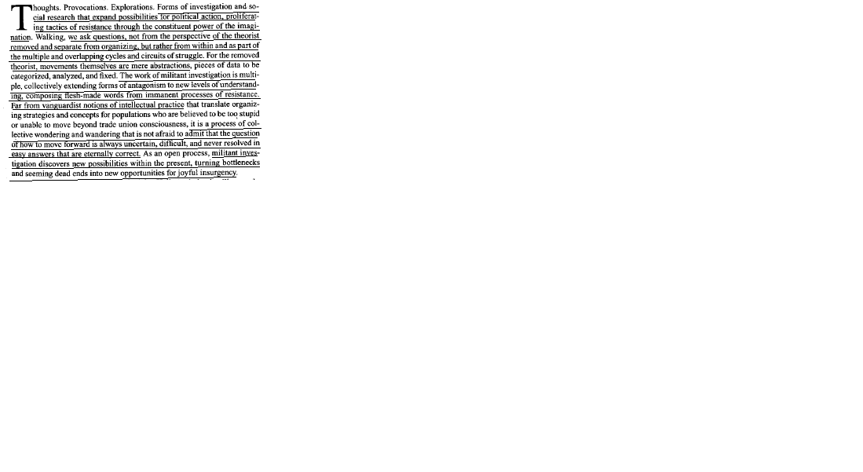

AT: Gibson Graham

Gibson Graham are wrong – only starting from negativity can open up true alternatives to capitalism
Holloway, Ph. D in poltical science, 7
(John Holloway, sociologist and phiolosopher, teacher at the Institute for Humanities and Scoail Sciences at the Autonomous University of Puebla, “Constituent Imagination: Militant Investigations, Collective Theorization,” February 2007, pg. 12)
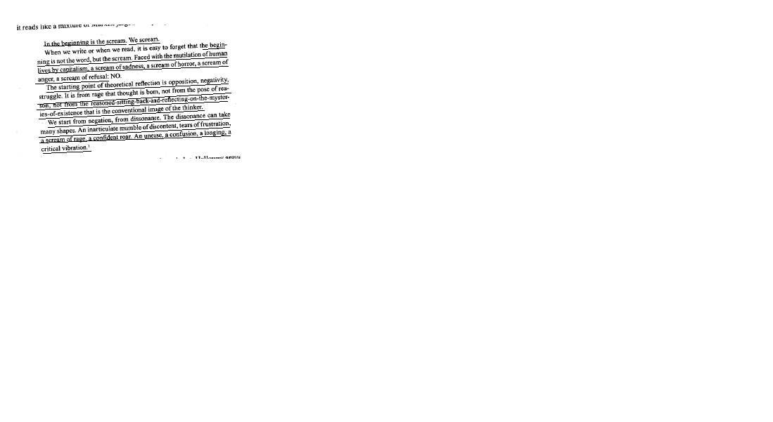

Alt Solves

The production of transformational knowledge embedded in process is key to overthrow capitalism – investigation from a critical distance fails
Greaber and Shukaitis, anthropologist and research fellow at Leicester, 7
(David Graeber and Stevphen Shukaitis, anthropologist and lecturer at Goldsmiths College, London, former associate prof Anthropology at Yale, and research fellow at the University of Leicester Centre for Philosophy and Political Economy, “Constituent Imagination: Militant Investigations, Collective Theorization,” February 2007, pg. 12)
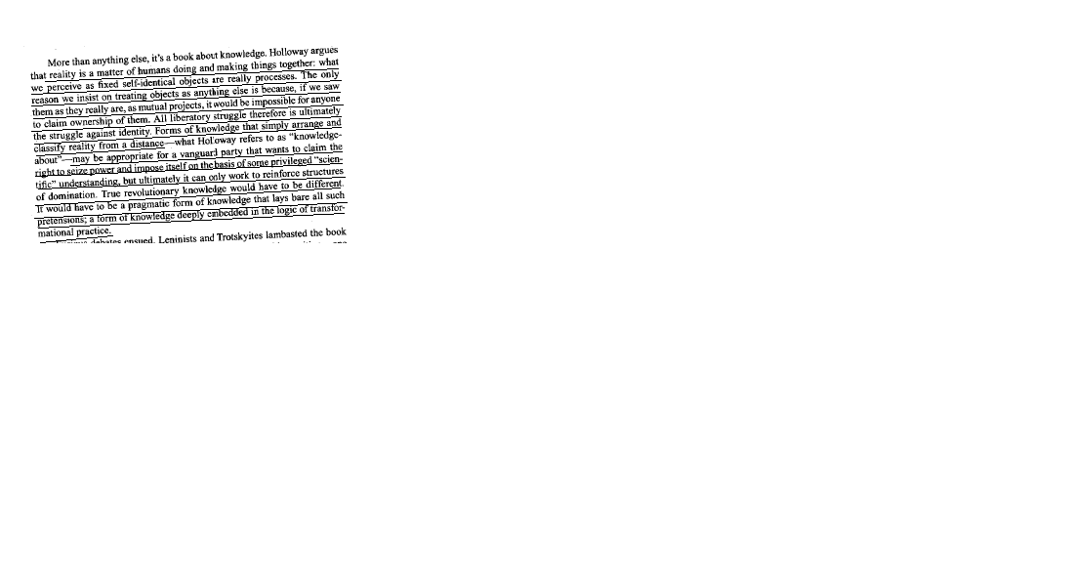

Aff: Reject/Debate is political alts fail

Alternative of pure knowledge as politics fail – the call for future action remains rooted in the ivory tower of the academy as real efforts for action are ignored
Greaber and Shukaitis, anthropologist and research fellow at Leicester, 7
(David Graeber and Stevphen Shukaitis, anthropologist and lecturer at Goldsmiths College, London, former associate prof Anthropology at Yale, and research fellow at the University of Leicester Centre for Philosophy and Political Economy, “Constituent Imagination: Militant Investigations, Collective Theorization,” February 2007, pg. 13-14)
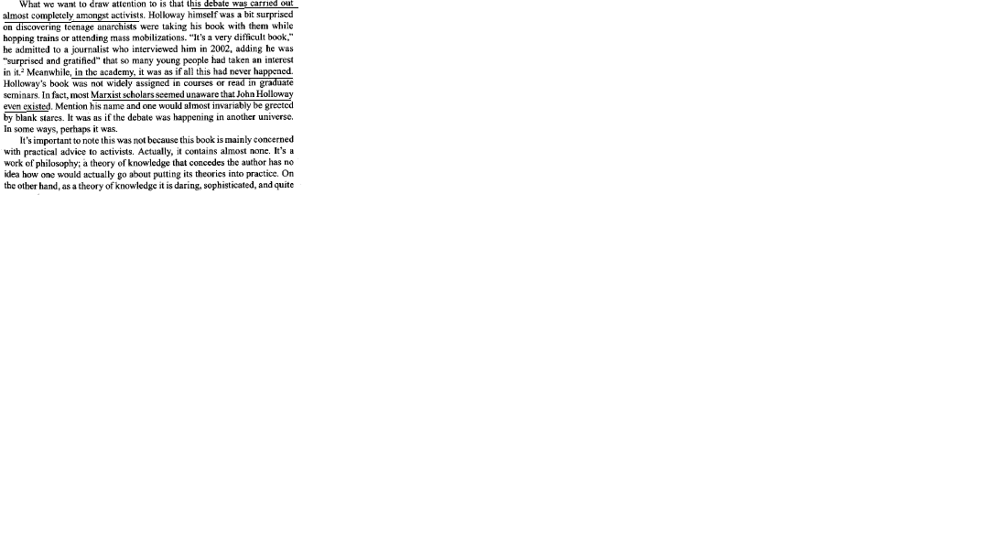
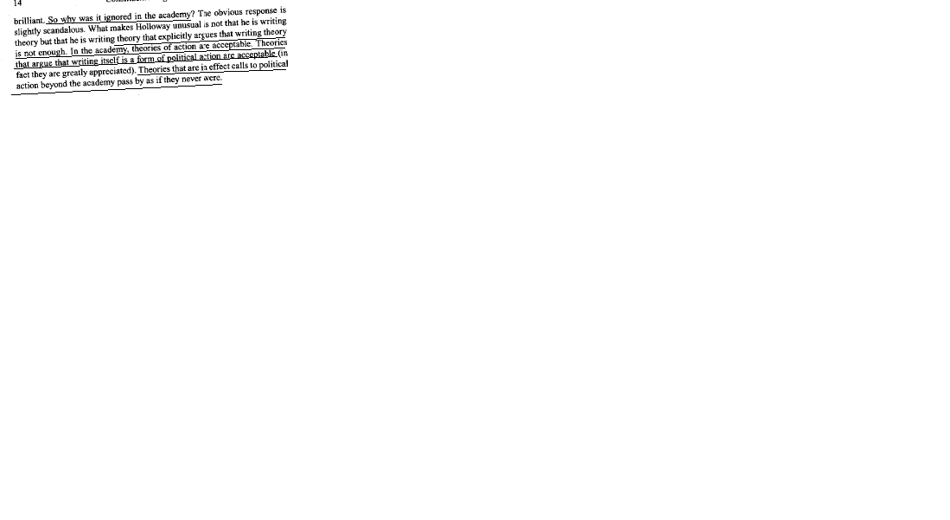

A2: Quals/their evidence biased

Their evidence is epistemologically flawed – the academy doesn’t produce creative or inclusive thinkers, but either authoritarian functionaries who promote the US’s neoliberal agenda or irrelevant social critics who overlook imperialist policies
Greaber and Shukaitis, anthropologist and research fellow at Leicester, 7
(David Graeber and Stevphen Shukaitis, anthropologist and lecturer at Goldsmiths College, London, former associate prof Anthropology at Yale, and research fellow at the University of Leicester Centre for Philosophy and Political Economy, “Constituent Imagination: Militant Investigations, Collective Theorization,” February 2007, pg. 14-16) 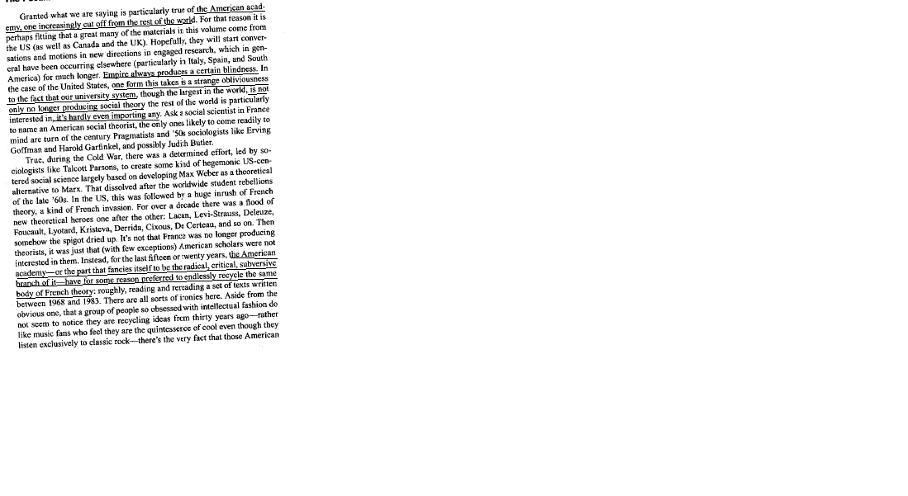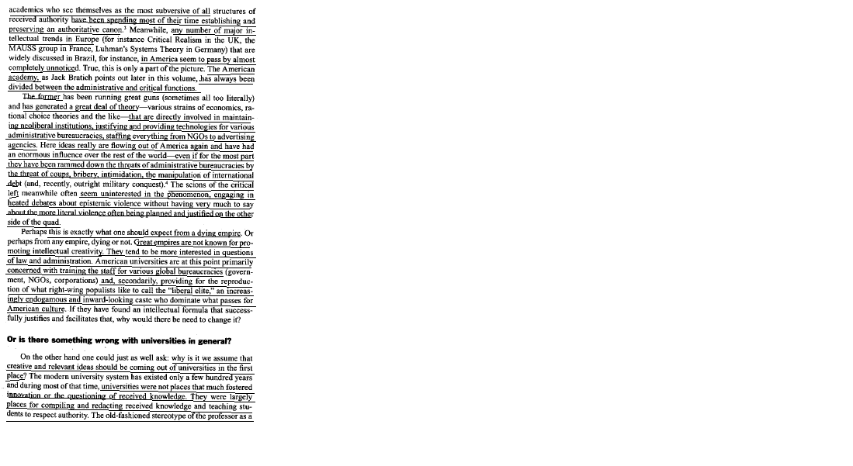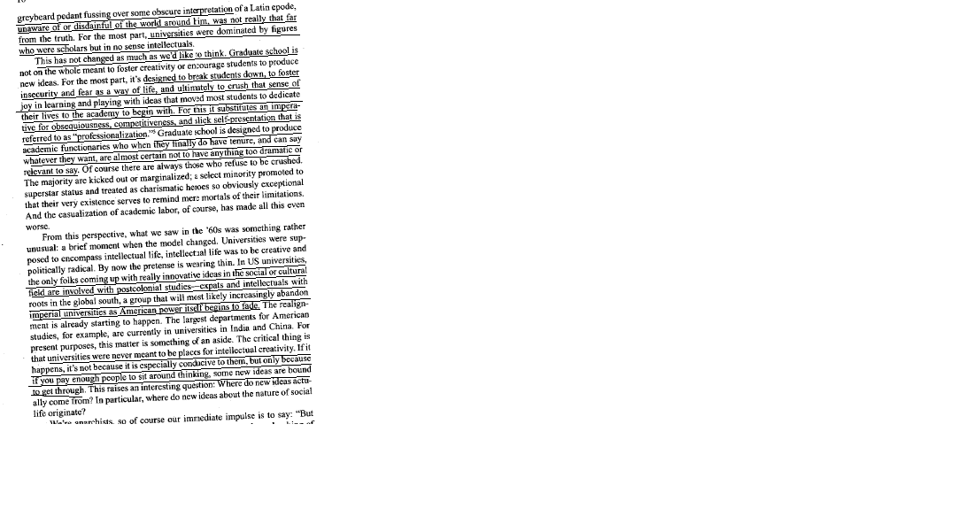

Aff: Alt = ivory tower

The alternative remains rooted in the ivory tower – advocating action is unheard of, only works that embrace their own practical irrelevance are found in the modern academy
Greaber and Shukaitis, anthropologist and research fellow at Leicester, 7
(David Graeber and Stevphen Shukaitis, anthropologist and lecturer at Goldsmiths College, London, former associate prof Anthropology at Yale, and research fellow at the University of Leicester Centre for Philosophy and Political Economy, “Constituent Imagination: Militant Investigations, Collective Theorization,” February 2007, pg. 22-23)
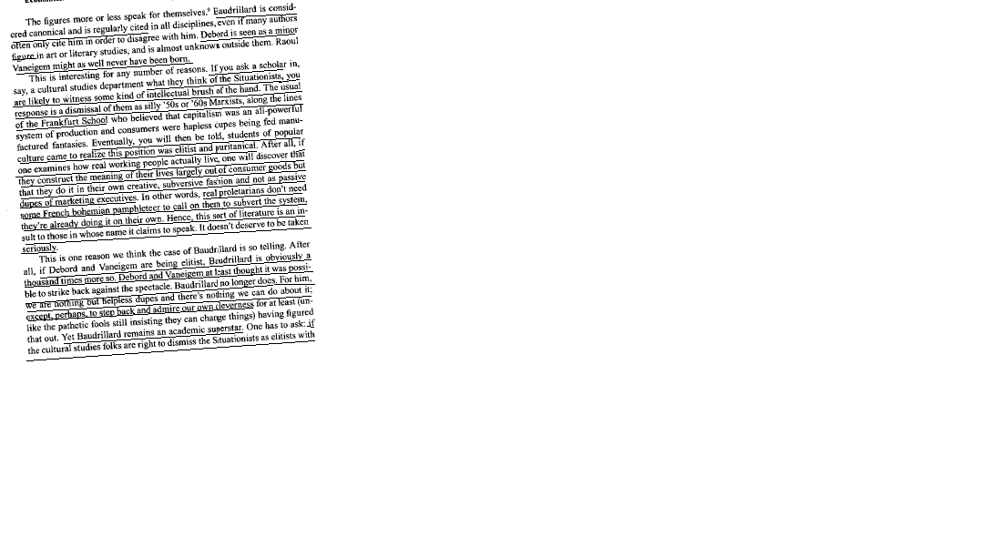
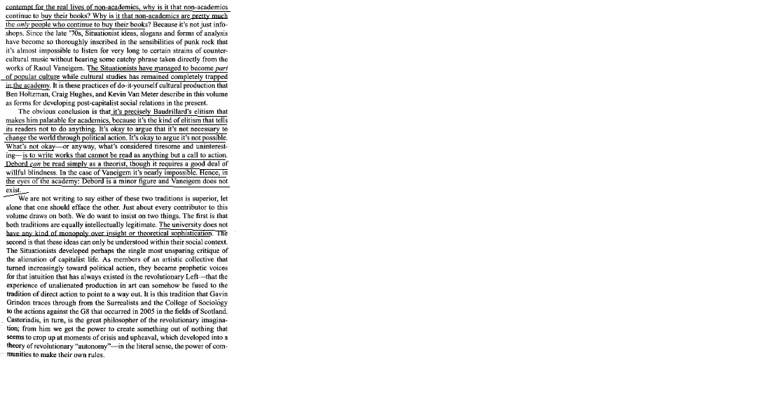

Alt Solves Even if Co-opted

Co-option is not a death sentence – even if the alternative fails, it forces capitalism to acknowledge the demands of ________ and accommodate for their needs
Greaber and Shukaitis, anthropologist and research fellow at Leicester, 7
(David Graeber and Stevphen Shukaitis, anthropologist and lecturer at Goldsmiths College, London, former associate prof Anthropology at Yale, and research fellow at the University of Leicester Centre for Philosophy and Political Economy, “Constituent Imagination: Militant Investigations, Collective Theorization,” February 2007, pg. 28-29)
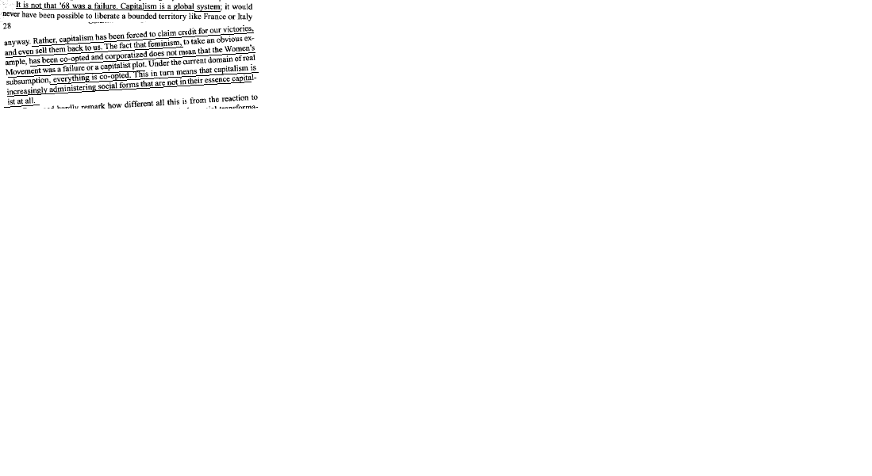

Alt Solves/L to some specific cases/!: Alienation

The alternative is key to resolve the alienation of modern institutions [[[[Like ________]]]]] – the combined role of the researcher and activist allows us to constantly move towards a more democratic society, forging our own social spaces for resistance along the way
Greaber and Shukaitis, anthropologist and research fellow at Leicester, 7
(David Graeber and Stevphen Shukaitis, anthropologist and lecturer at Goldsmiths College, London, former associate prof Anthropology at Yale, and research fellow at the University of Leicester Centre for Philosophy and Political Economy, “Constituent Imagination: Militant Investigations, Collective Theorization,” February 2007, pg. 31-33) 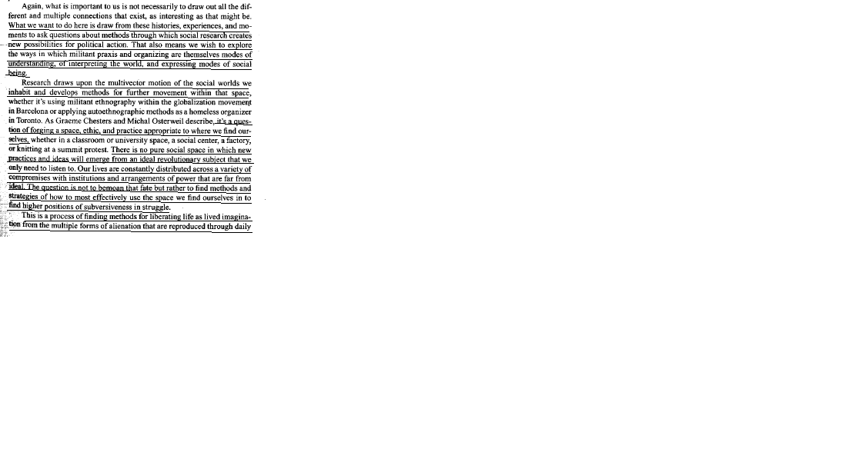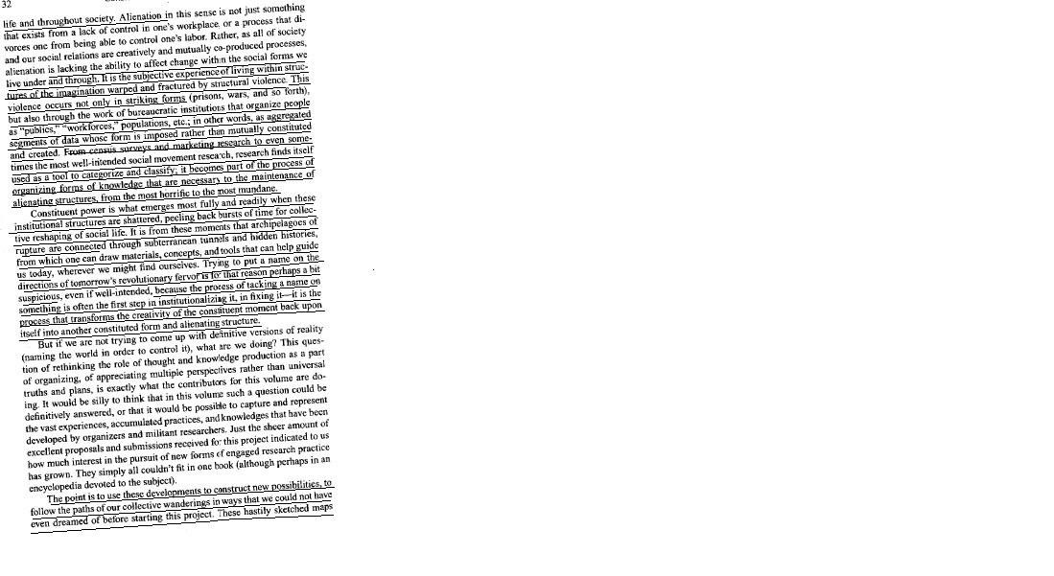
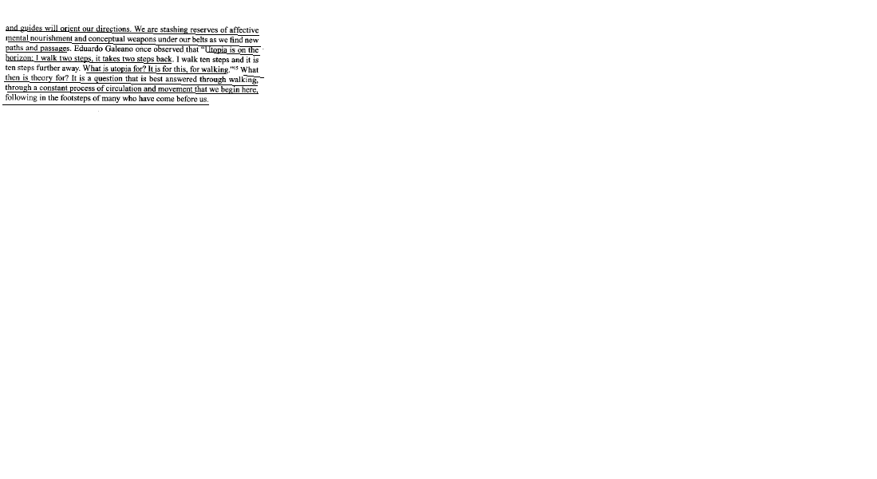

Leap of Faith Key

Taking a leap of faith is necessary for any alternative – only in embracing the revolutionary possibility of the moment are social boundaries dissolved and new forms of organization created
Greaber and Shukaitis, anthropologist and research fellow at Leicester, 7
(David Graeber and Stevphen Shukaitis, anthropologist and lecturer at Goldsmiths College, London, former associate prof Anthropology at Yale, and research fellow at the University of Leicester Centre for Philosophy and Political Economy, “Constituent Imagination: Militant Investigations, Collective Theorization,” February 2007, pg. 37-38)
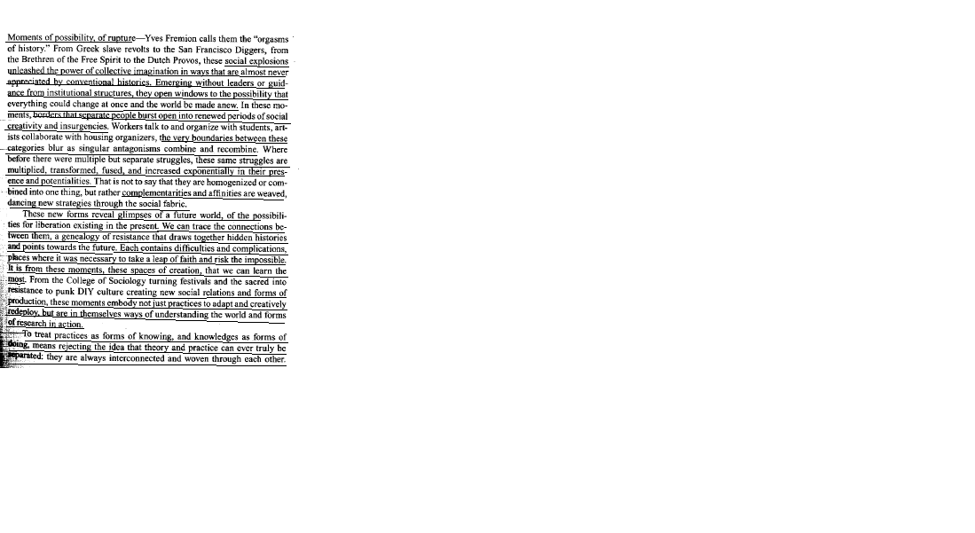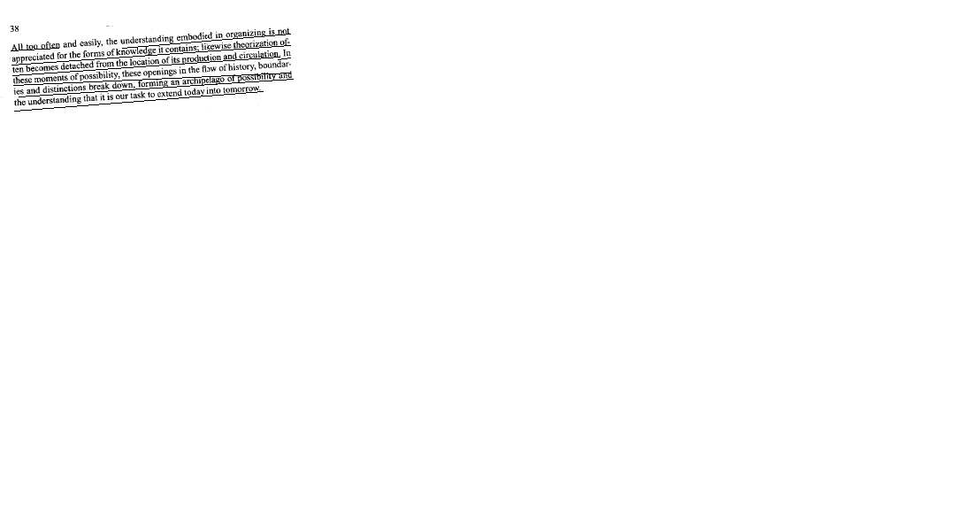

Alt: Activist-Researcher

The role of the activist-researcher is crucial to dissolve the borders of normative categories of study while simultaneously acting out independent theories of resistance to create new modes of relation and production
Holmes, theorist, 7
(Brian Holmes, theorist, writer, and translator, doctorate in Romance Languages and Literature,, “Constituent Imagination: Militant Investigations, Collective Theorization,” February 2007, pg. 41-43)
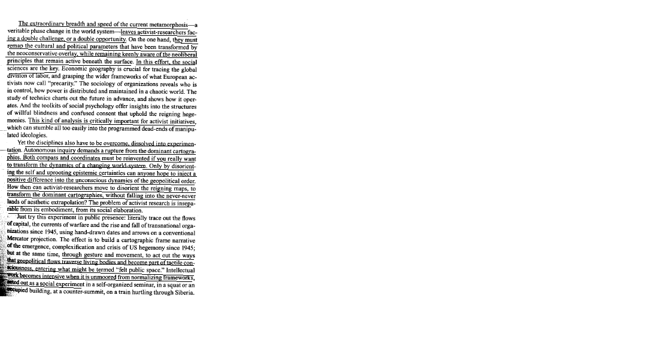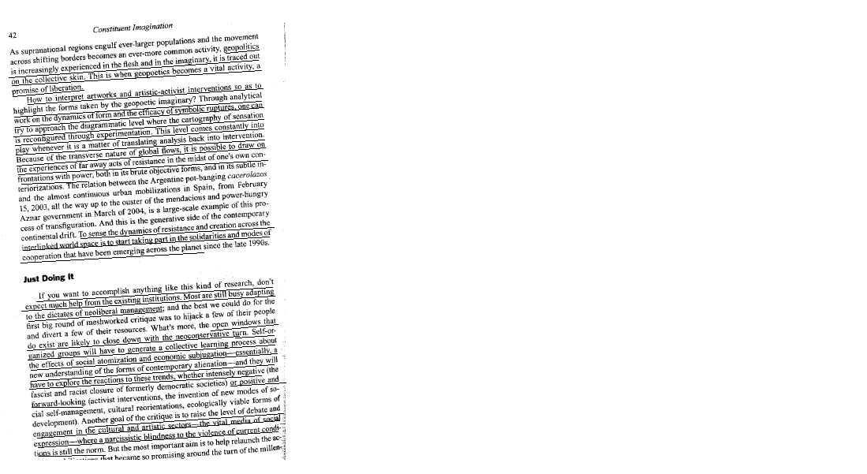
tivist mobilizations
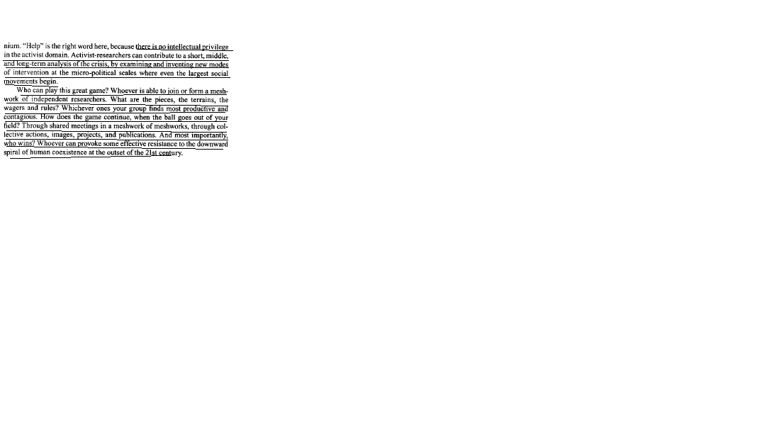

Alt: Do It Yourself Micropolitics

Embracing the ethic of Do It Yourself is a vital means of undermining capitalism while forming alternative means of social and political relations based around grass-roots direct-democracy
Holmes, theorist, 7
(Ben Holtzman, independent researcher and editor in New York, Kevin Van Meter, grad student @ Univ New York, Craig Hughes, activist and researcher, masters degree in history, “Constituent Imagination: Militant Investigations, Collective Theorization,” February 2007, pg. 44-46)
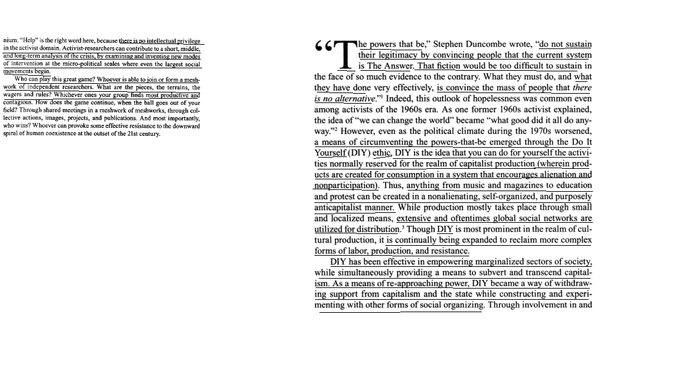
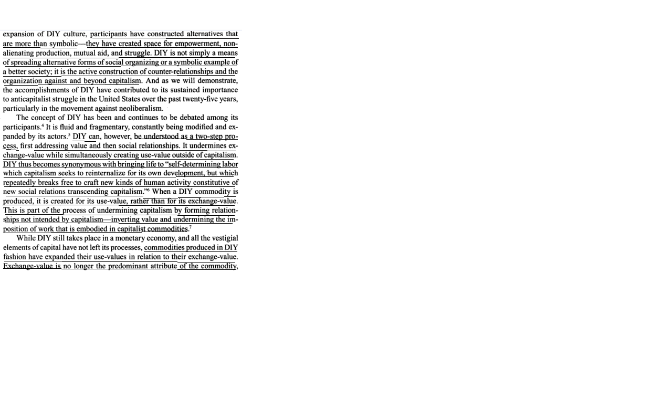
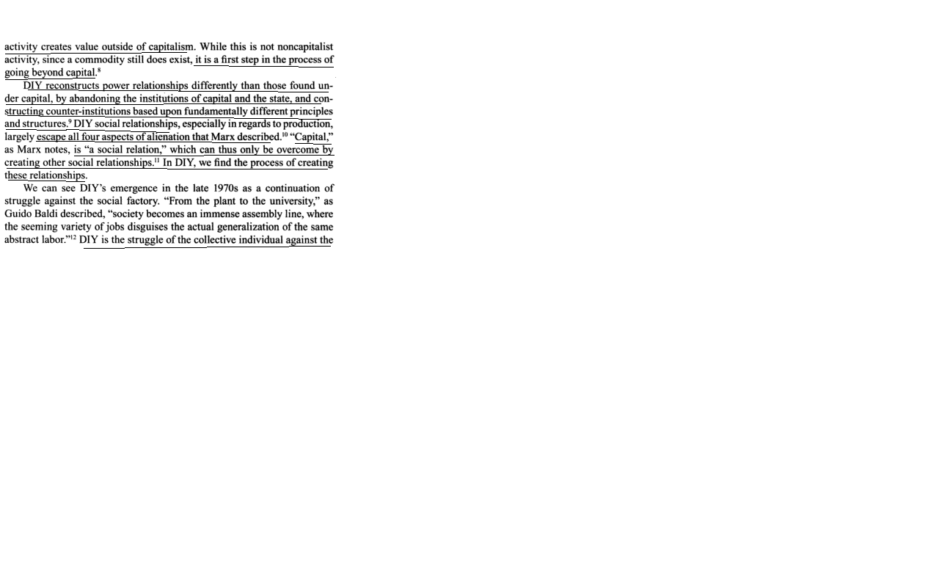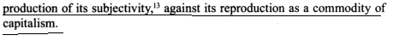

DIY Solves Information/Women Empowerment
The DIY ethic solves information spread – Zines that help empower women and others to act
Holmes, theorist, 7
(Ben Holtzman, independent researcher and editor in New York, Kevin Van Meter, grad student @ Univ New York, Craig Hughes, activist and researcher, masters degree in history, “Constituent Imagination: Militant Investigations, Collective Theorization,” February 2007, pg. 48-49)
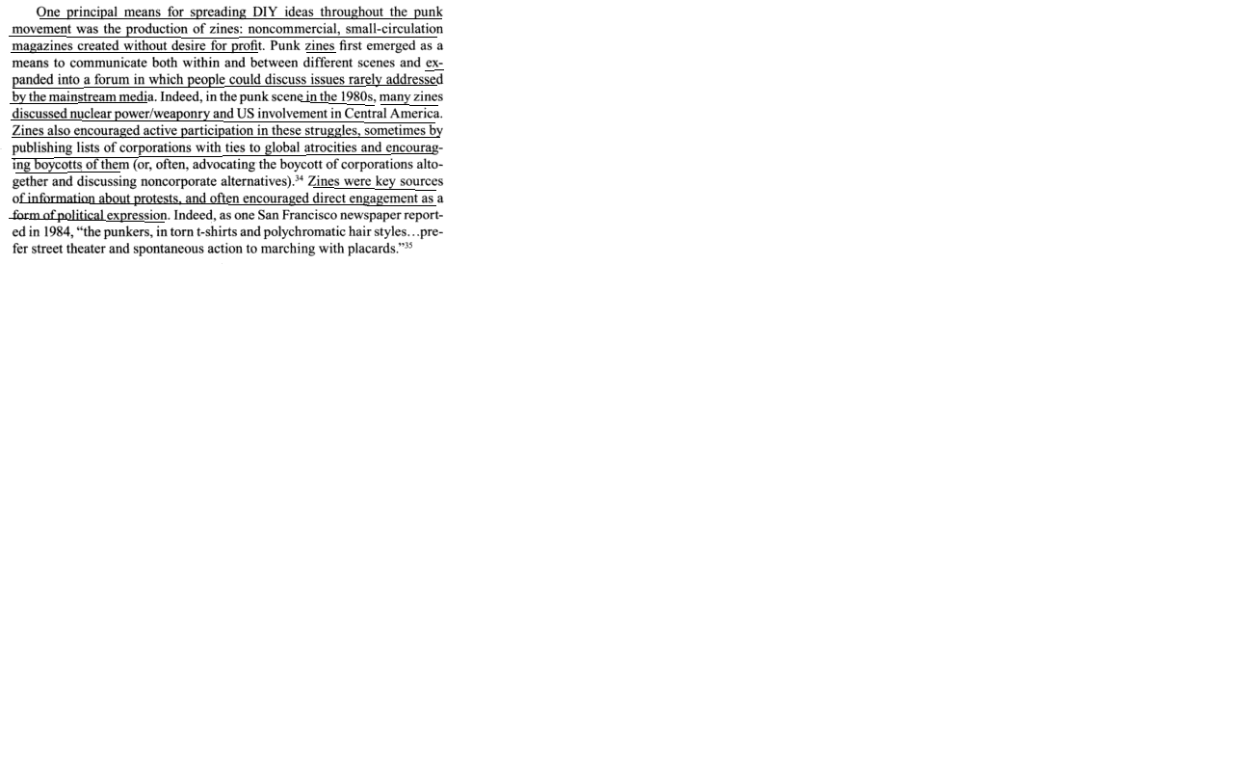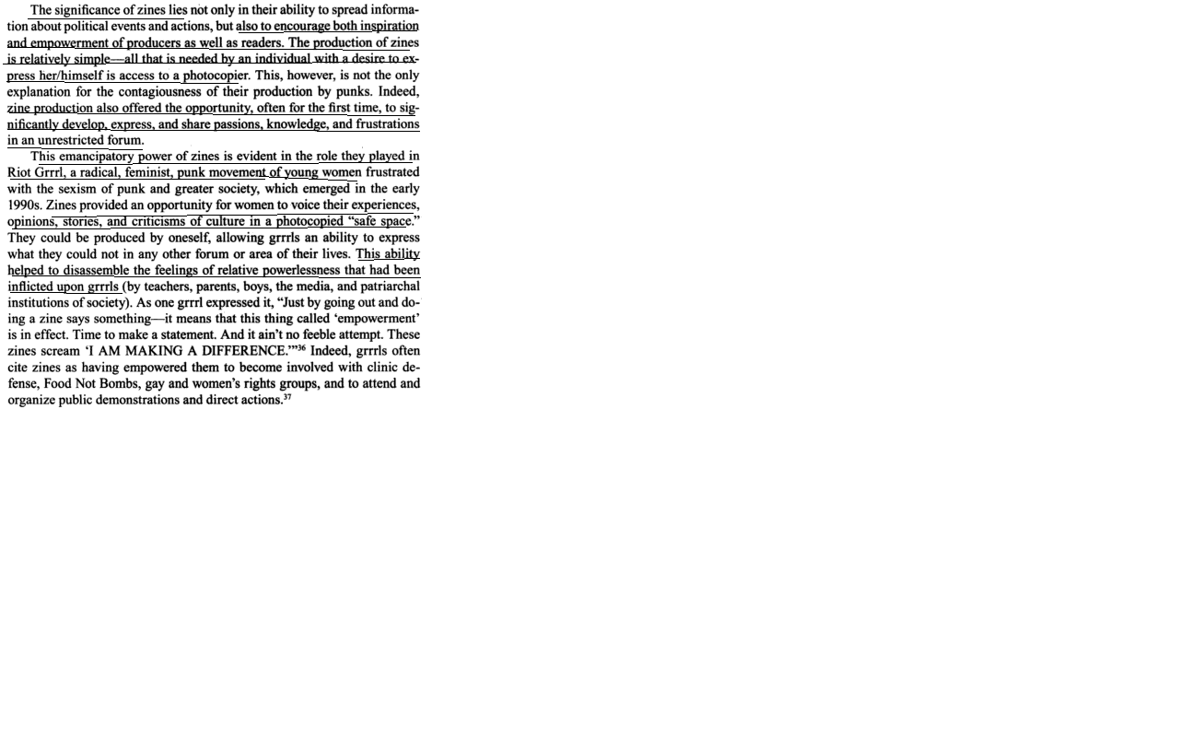

DIY Solves Food/undermines Cap

The DIY ethic solves food availability while simultaneously undermining capitalist structures
Holmes, theorist, 7
(Ben Holtzman, independent researcher and editor in New York, Kevin Van Meter, grad student @ Univ New York, Craig Hughes, activist and researcher, masters degree in history, “Constituent Imagination: Militant Investigations, Collective Theorization,” February 2007, pg. 49-50)
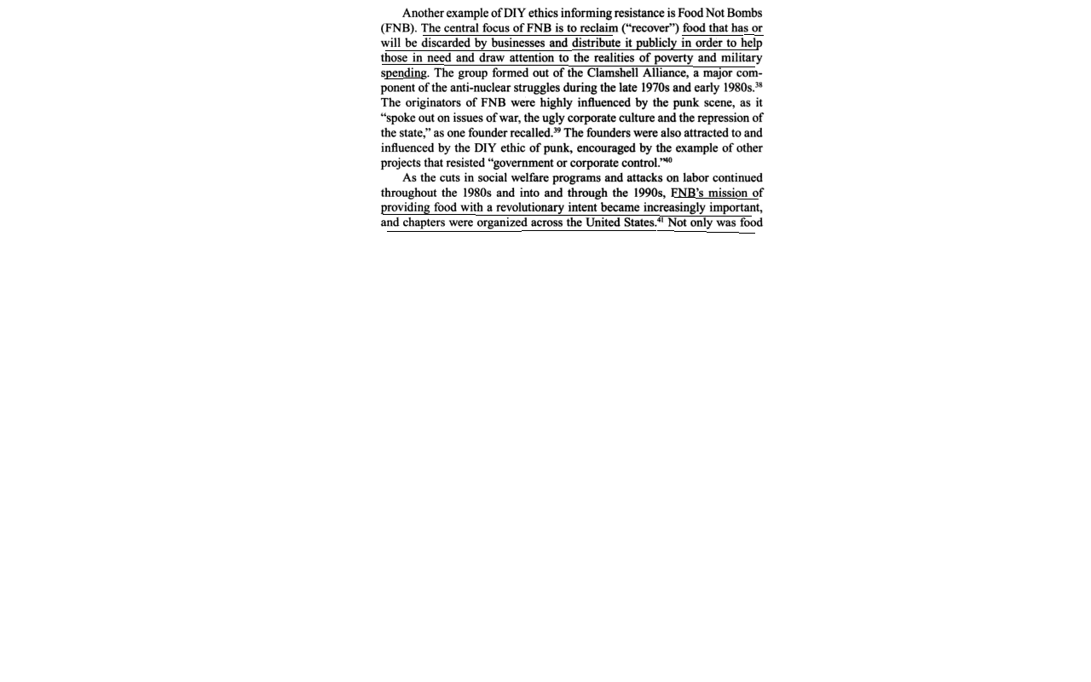
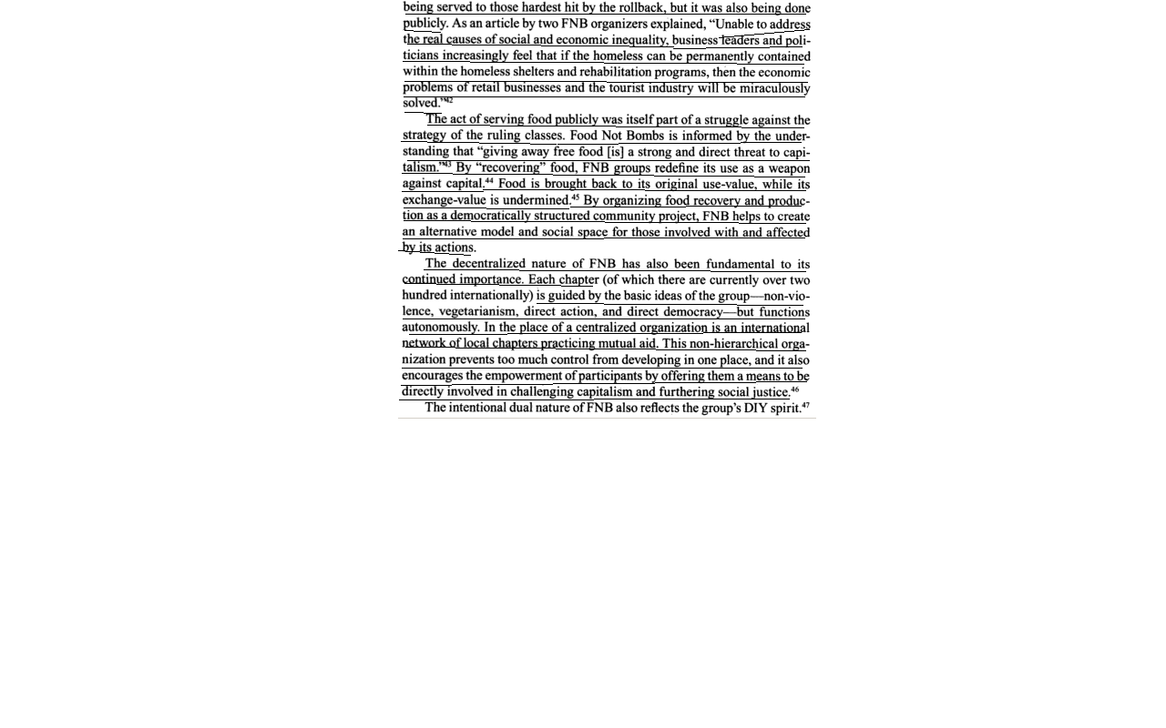
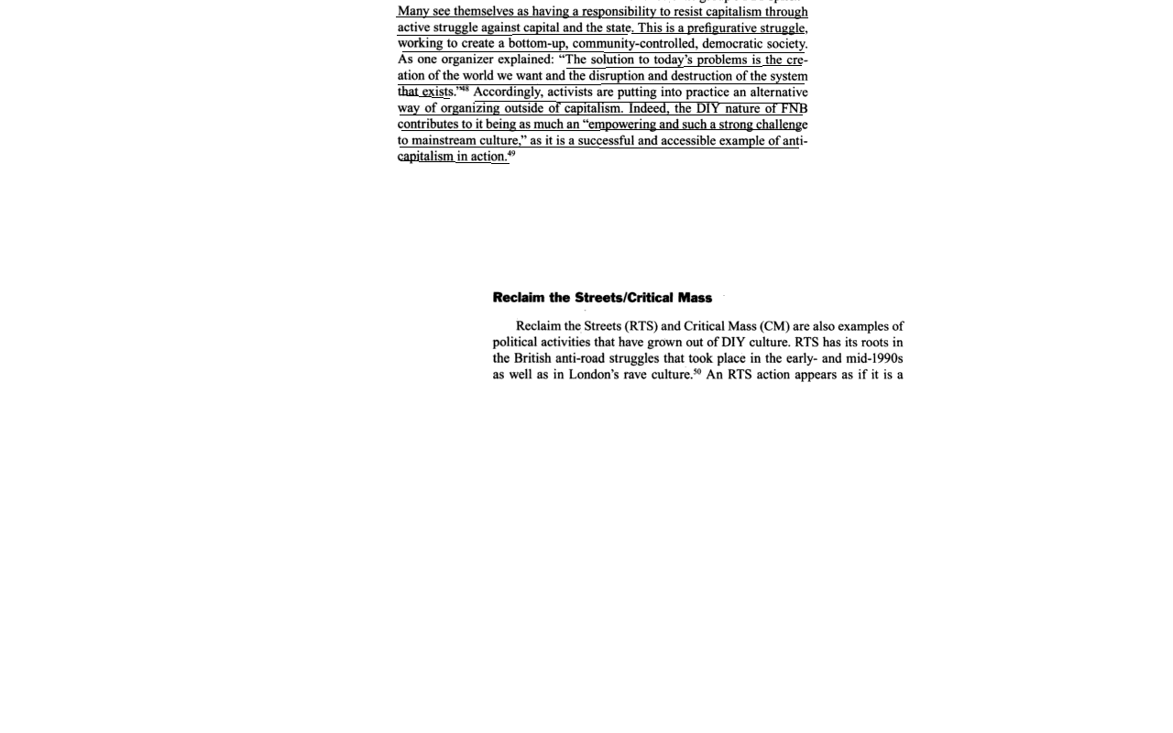

DIY Solves

The DIY ethic promotes direct action and reclamation of public spaces that helps to undermine capitalist power
Holmes, theorist, 7
(Ben Holtzman, independent researcher and editor in New York, Kevin Van Meter, grad student @ Univ New York, Craig Hughes, activist and researcher, masters degree in history, “Constituent Imagination: Militant Investigations, Collective Theorization,” February 2007, pg. 44-46)
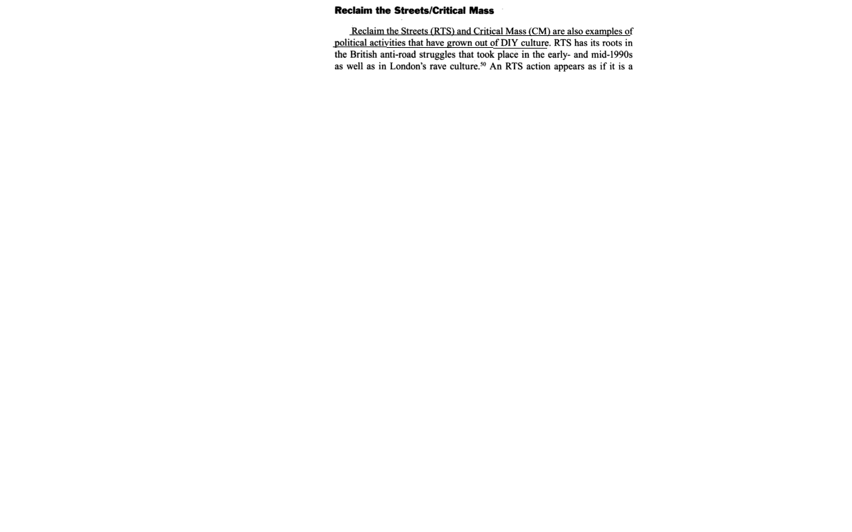
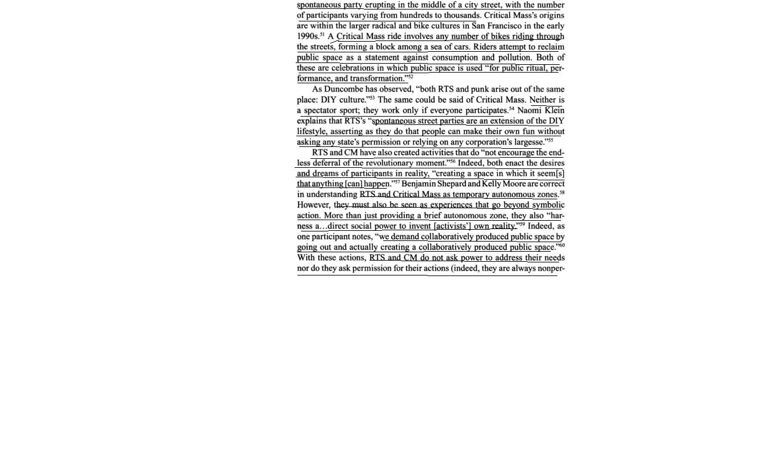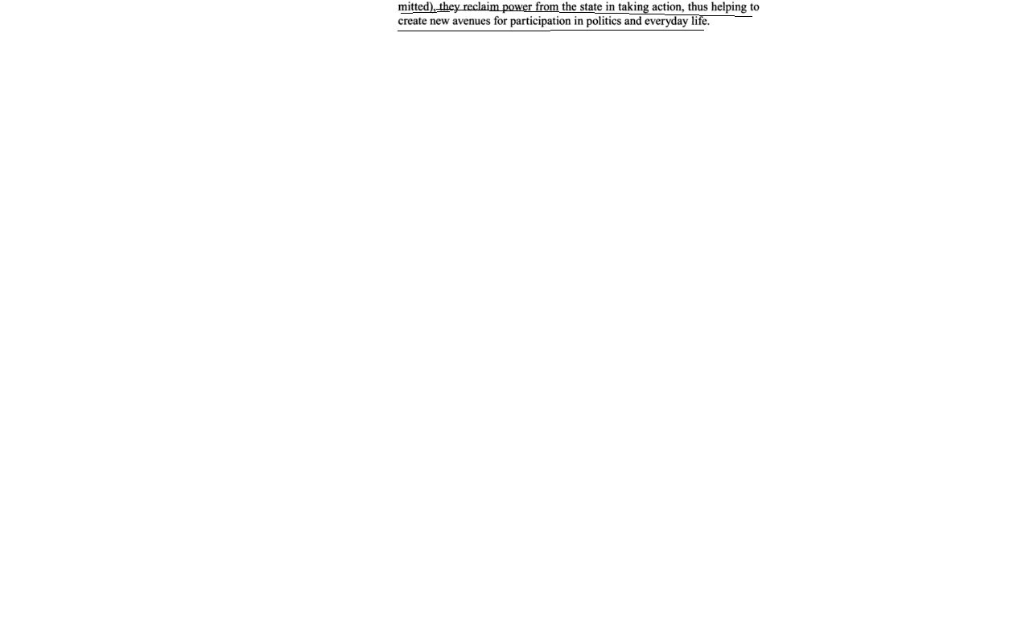

DIY Solves

The DIY ethic is key to organizing against capital and forming autonomous means of social organization and production
Holmes, theorist, 7
(Ben Holtzman, independent researcher and editor in New York, Kevin Van Meter, grad student @ Univ New York, Craig Hughes, activist and researcher, masters degree in history, “Constituent Imagination: Militant Investigations, Collective Theorization,” February 2007, pg. 44-46)
